SPECIFICATION

Comfort Zone™

Knit Shirt

A Top Brass® professional uniform

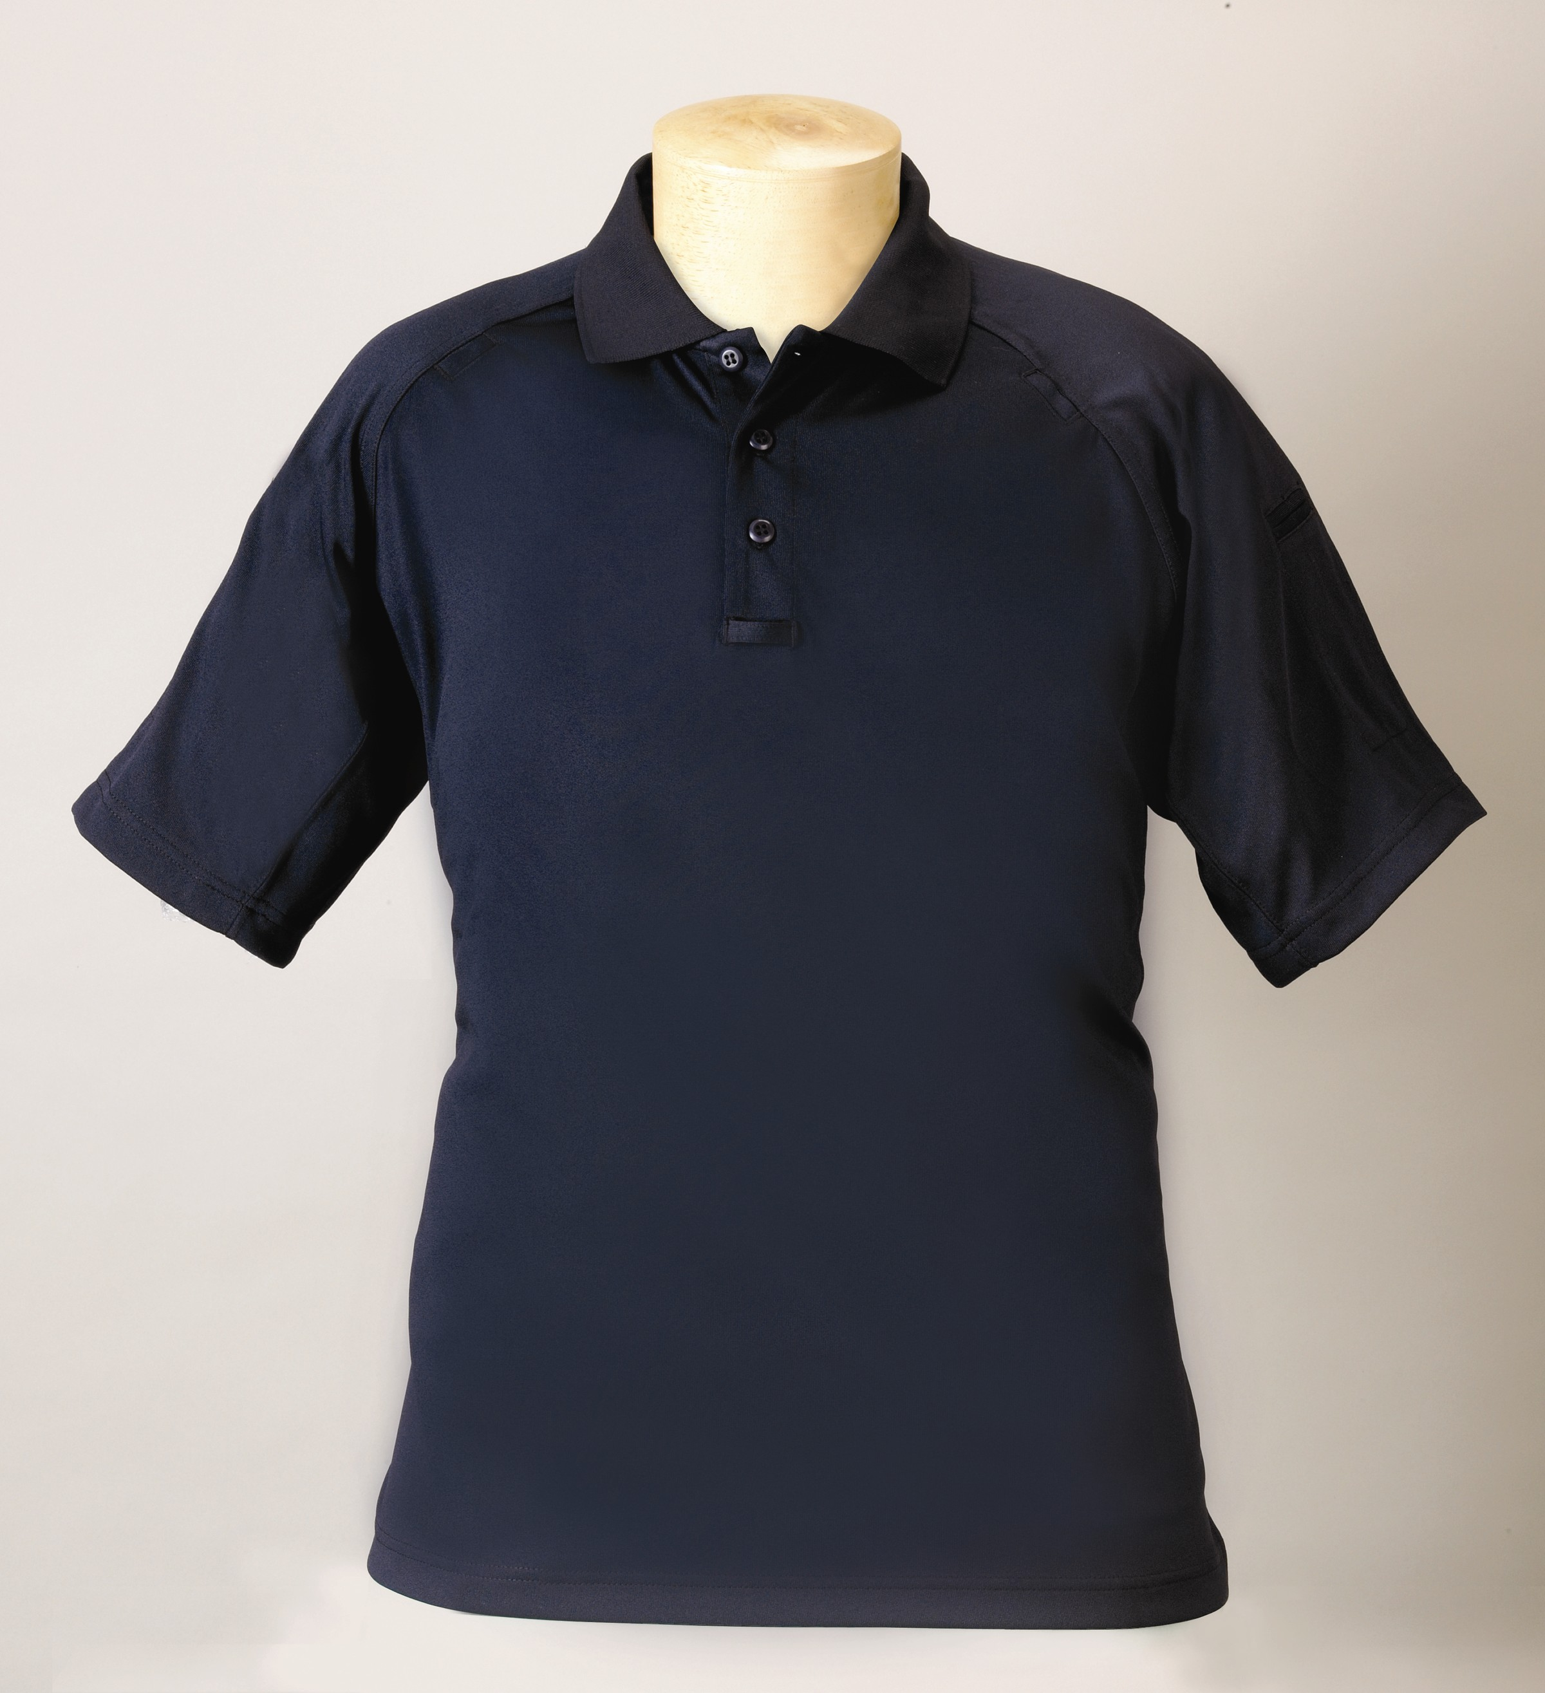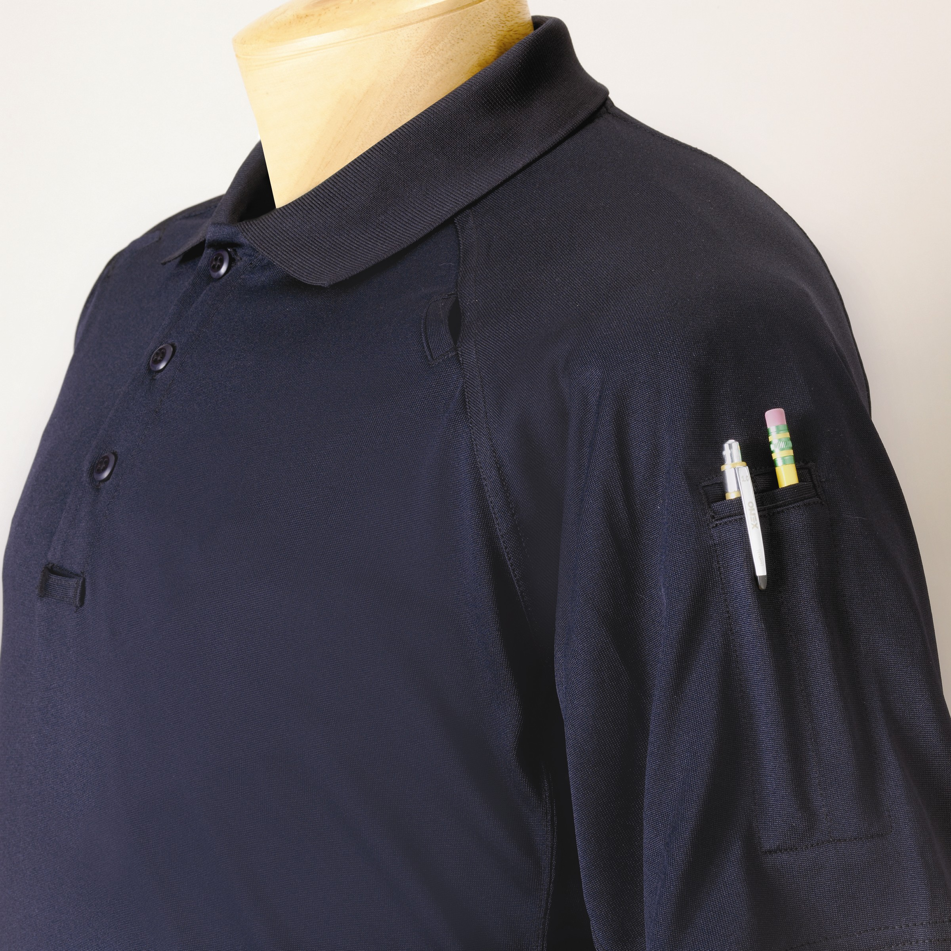

STYLE #: 788MBK - Black

788MKH - Khaki

788MNV – Navy

788MWH - White

STYLE: Knit shirt, pullover, 3-button placket front, knit collar, hemmed cuffs, tennis tail, side vents, raglan sleeve, microphone tabs

FABRIC:

Contents: 100% polyester
Yarns: 20’s, combed
Knit: Jersey
Weight: 8.45 ozs./sq. yd., 240 gms/sq. meter
Dying: Reactive dyes
Finish: Moisture management, antimicrobial

FRONT PLACKET: There shall be a 3 button placket front, averaging 7” long and 1 ½” wide. There shall be 3 matching color melamine buttons to the body of the shirt, 4-hole with an “x” stitch. The placket shall be double stitched at the bottom. There shall be a heavy-duty interlining inside the placket. There shall be a microphone tab across the bottom of the placket. This shall be made of self-material. It shall be 1-1/2” left to right and ¾” high. There shall be bartacks on all four corners. It shall be interlined with non-stretch canvas or heavy non-woven material.

COLLAR: There shall be a standard knit type collar. This shall be a non-curl type collar with thin collar stays inserted inside to prevent curling. The seam attaching the collar to the body of the shirt shall be fully taped to avoid stretching.. The collar shall identically match the body color of the shirt.

SHOULDER SEAM: In the top shoulder seam on both the left and right sides approximately 4” from the neck seam, there shall be a small “pocket” with interior pocket bag. The opening shall be 1-1/4” wide. It shall be 2” deep. This shall serve as a pouch for a microphone clip. There shall be a bartack at each corner opening. The shoulder seam shall be topstitched. These seams shall include a tape to avoid stretching.

SLEEVES: There shall be a raglan style sleeves. Set into the front seam on both the left and right sides, approximately 4” from the neck seam, there shall be a small “pocket” with interior pocket bag. The opening shall be 1-1/4” wide. It shall be 2” deep. This shall serve as a pouch for a microphone clip. There shall be a bartack at each corner opening.

There shall be an inset pen pocket on the left sleeve. This shall be 1-3/4” wide and 5” deep. There shall be a small double welt opening, reinforced with a firm interlining. There shall be a bartack at each side.

These seams shall include a tape to avoid stretching.

UNDERARM MESH VENT: There shall be an under arm gusset style mesh vent to further allow the shirt to breathe. This shall be made of a tight mesh material in the identical color as the shirt. This oval shaped gusset shall measure approximately 2” wide and 4-1/2” in total height.

SIDE VENTS & BACK TAIL: There shall be a side vent on each side of the shirt. There shall also be a longer back “tennis tail” (approximately 1-1 ½” longer than the front).

SEAMING: All armhole and shoulder joining seams shall be overlock safety stitched and then double needle topstitched with a ¼” wide stitch on the outside. The side seams shall be overlock safety stitched. There shall be a 1” wide hem at the bottom front and back. The shoulder seam shall have stay tape to prevent stretching.

THREAD: All thread shall be poly-core

FADING: The use of reactive dyes shall prevent this garment from fading for a minimum of 50 machine washings.

FINISHING: This garment shall be finished in a first class workmanlike manner with all loose threads removed. The omission or apparent omission of any wording or specifications shall mean that only the highest quality industry standards shall be used on all fabric and component parts including labor. Where there may be a discrepancy between the standard sample and the written specification, the detail of the standard sample shall prevail.

LABELS: All labels will be permanent to withstand repeated cleanings for the life of the garment. The following labels shall be applied:

MAIN LABEL: This shall identify the manufacturer either by name & location, registered trademark or WPL or RN number as required by the Federal Trade Commission.

CONTENTS/CARE/SIZE LABEL: There shall be an additional label clearly showing the fabric contents, laundering instructions and garment size.

SIZES:

 | X-Small | Small | Medium | Large | X-Large | 2X-Large | 3X-Large | 4X-Large | 6X-Large
SIZE: | 30-32 | 34-36 | 38-40 | 42-44 | 46-48 | 50-52 | 54-56 | 58-60 | 66-68
Chest: | 36 | 40 | 44 | 48 | 52 | 56 | 60 | 64 | 72
Back length: | 26 | 28 | 30 | 31 | 32 | 33 | 34 | 35 | 37
Sweep: | 35 | 39 | 43 | 47 | 51 | 55 | 59 | 63 | 71
Neck: | 15.5 | 16.5 | 17.5 | 18.5 | 19.5 | 20.5 | 21.5 | 22.5 | 24.5
Sleeve: (1/2) | 6.5 | 7 | 7.5 | 8 | 8.5 | 9 | 9.5 | 10 | 12
Collar Height: | 3 | 3 | 3 | 3 | 3 | 3 | 3 | 3 | 3
Collar Point: | 3 | 3 | 3 | 3 | 3 | 3 | 3 | 3 | 3
Placket length: | 6 | 6.5 | 7 | 7 | 7 | 7 | 7 | 7 | 7
Placket Width: | 1.5 | 1.5 | 1.5 | 1.5 | 1.5 | 1.5 | 1.5 | 1.5 | 1.5
Sleeve length: (in sleeve) | 6.5 | 7 | 7.5 | 8 | 8.5 | 9 | 9.5 | 10 | 11
Back drop tail: | 1.5 | 1.5 | 1.5 | 1.5 | 1.5 | 1.5 | 1.5 | 1.5 | 1.5

