SPECIFICATION

Comfort Zone®

Class A Coolmax Shirt

A Top Brass® professional uniform

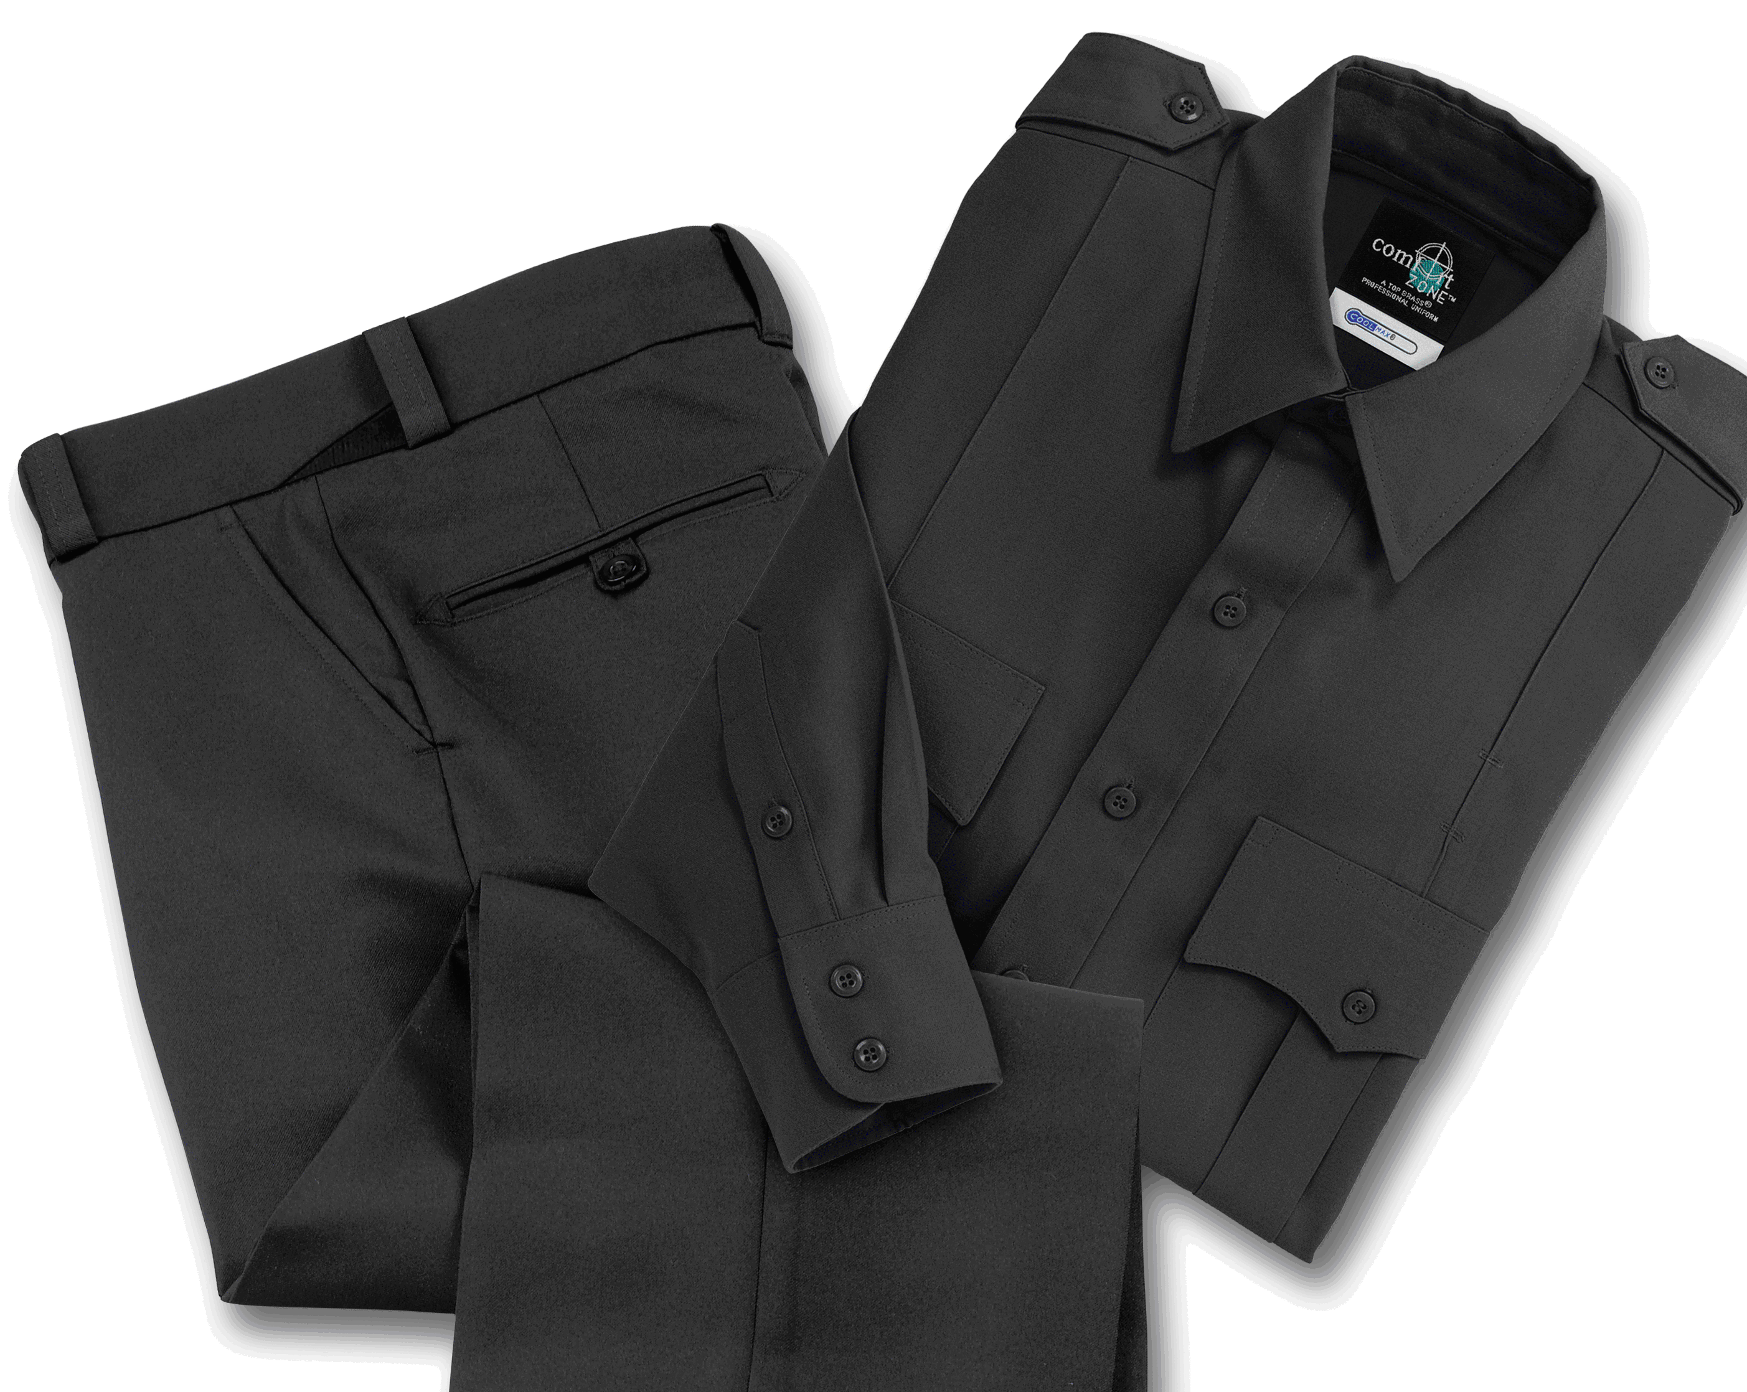

STYLE #: Long Sleeve - male Short Sleeve - male

#740MNV – Navy #750MNV – Navy
#740MWH – White #750MWH - White

STYLE: Dress uniform shirt, seven (7) button placket front, banded collar (L/S), convertible collar (S/S), two (2) pleated patch pockets, scalloped flaps with hook & loop closure, pencil opening in left flap, sewn-in military creases front and back, epaulets, barrel cuff with placket vent and center button (L/S), sling badge tab, expandable tab collar.

FABRIC SUMMARY:

Contents: 66% Coolmax®

34% polyester

Construction: Warp = 154, Filling = 55
Yarns: Warp = 1-ply, 150 denier CoolMax® polyester, 176 filaments
Filling = 1-ply, 150 microdenier polyester, 200 filaments
Weave: Oxford
Weight: 9.66 ozs./linear yd. (60”)
5.8 ozs/sq.yd.
Stretch: ESP® comfort stretch: 1-4% warp, 10-14% filling
Dying: Vat dyed
Finish: Nano-dry™ technology provides comfort of cotton with strength and performance of synthetics. Features superior moisture management technology. Stain release.

FABRIC TEST RESULTS:

Test Name, Reference and KTEST # Test Detail Specification Applicable to:

* Colorfastness to Abrasion (Frosting) 1200 cycles > 3.5 Spun Fabrics only
AATCC 119
A-01

* Colorfastness to Crocking Dry > 4.0 All dark shades
AATCC 8 Wet > 3.0 All dark shades
A-03

Optical Migration No Discoloration Frame applied Optical only
A-04 Development Lots and Process Changes

* Colorfastness to Light 20 hours > 4.0 All lots
AATCC 16 - 1993 option A
A-05

* Colorfastness to Perspiration - Acid Shade Change > 4.0 All lots
AATCC 15 Staining > 3.0 Grade only Cotton and Polyester fibers
A-06

* Colorfastness to Washing - IIA Shade Change > 4.0 All lots
AATCC 61 - 1993 Staining > 3.0 Grade only Cotton and Polyester fibers
A-08

* 120ºF Wash Shrinkage 3 Wash/Dry cycles < 3.0% All lots
B-01 at 120ºF < 4.0% Poly/wool, Poly/Rayon and Nylon

Test Name, Reference and KTEST # Test Detail Specification Applicable to:

* Press Shrinkage 15 sec. at 325ºF < 3.0% All Lots
B-03

Appearance After Laundering 3 wash/dry cycles > 3.5 Development Lots Only
C-01 at 120ºF

Brush Pilling > 3.0% Spun Only
ASTM D3511
C-02

* Pilling - Random Tumble 60 min. None Development Lots Only
ASTM D3512
C-03

* Roughing and Pilling original 15 min. > 4.0 All lots
C-05 60 min. > 3.0
3X at 120ºF 15 min. > 4.0
60 min. > 3.0

* Seam Slippage > 20 lb. Fabric weight < 3.0 oz./yd²
ASTM D434 > 30 lb. Fabric weight > 3.0 oz./yd²
C-06

* Stretch and Recovery Stretch Varies with Style
ASTM D 3107 Non-Lycra Recovery (30 min.) < 5.0% Non-Lycra Styles with Stretch > 20%
C-07 Lycra Recovery (60 min.) < 4.0% Lycra Styles

* Tensile Strength > 30 lb. Fabric weight < 3.0 oz./yd²
ASTM D 5034 > 50 lb. Fabric weight > 3.0 oz./yd²
C-09

Texture Distortion 4 lb. load < 0.10 in. Menswear
ASTM D1336 2 lb. load < 0.15 in. Womenswear
C-10

* Elmendorf Tear > 1000g Fabric weight < 3.0 oz./yd²
ASTM D1424 > 1500g Fabric weight > 3.0 oz./yd²
C-04

Flammability - 16 CFR 1610 Class 1 Hand Standards
F-1

Mark Off Varies by Style Pass

* Tests that are required when applicable on Color Standard lots.

FRONT: Long Sleeve - There shall be a full separate placket on the left front, 1 ½” wide, sewn on, having one buttonhole on the collar stand and buttonholes on the front spaced 3 ½” apart. The right front shall be plain with a minimum turned back facing of 1 ¼”. There shall be no raw edge on this facing. 20 ligne buttons shall be attached to the right with corresponding buttonholes on the placket. There shall be an extra button at the bottom of the right front.
Short Sleeve – There shall be a mock placket on the left front, 1 ½” wide. The right front shall be plain. The turned back material behind both the left and right fronts shall be approximately 3”. The raw edges shall be serged. 20 ligne buttons shall be attached to the right with corresponding buttonholes on the placket. There shall be an extra button at the bottom of the right front.

POCKETS: There shall be two (2) pleated patch pockets. They shall be 5 ½” wide with mitered corners and 6 ½” high (finished with flap). There shall be a center pleat 1 ½” wide. The flap shall be 5 ½” wide, scalloped type. The flap shall finish clean underneath. The sides shall be 2 ½” high and the center shall be 2 ¾” high. There shall be a vertical stitched in crease through the center of the flap and in the center of the pleat in the pocket. There shall be a 1” wide pencil opening in the left flap to correspond with the sewn in pencil compartment in the left pocket. Topstitching shall be 1/32” on all sides of the pockets and flaps with a double needle stitch spaced ¼” at the top of the flaps. There shall be a stitched closed buttonhole and non-functioning 20-ligne button, both on the flap. The flaps shall close with a hook and loop closure under each corner of the flap. This shall identically match the color of the shirt.

COLLAR: There shall be a banded collar on both the long sleeve and the short sleeve. The points shall be 3 ¼” long. There shall be permanent collar stays. The interlining shall be woven polyester or canvas. The collar shall be topstitched ¼” from the edge and shall close with a 20 ligne button.

EXPANDABLE COLLAR: The button at the neck on the collar band shall be attached to a ½” wide self-material tab. This tab shall insert into a vertical buttonhole on the outside ply of the collar band and be sandwiched between the outside and inside collar band. This tab shall then attach to a ½” elastic strap. This strap shall be sewn to the outer collar band. The button shall then be capable of stretching up to 1” to increase the neck size.

SLEEVES: Long sleeves shall be straight and whole with pleats, gauntlet style. Top placket on the sleeve vent shall measure 1” wide and 6” long to the point, with a 5” opening. Bottom welt shall be ½” wide. There shall be a center button and buttonhole in the placket.
CUFF: Barrel cuff on the long sleeve shall be 2 7/8” wide with a two (2) button closure, set vertically.

YOKE & BACK: There shall be a two (2) piece yoke, stitched and turned. Yoke shall be 3 ¼” below the collar seam in back.

EPAULETS: There shall be two (2) “X” stitched epaulets made of two plies of self-material with a button closure. These shall be interlined with woven polyester or canvas material. The pointed end shall finish ½” from the neck seam. They shall measure 1 ¾” wide at the shoulder seam and taper to 1 ½” by the button, and then come to a point.

BADGE TAB: There shall be a sling type badge holder. The sling, made of shell material and color, shall be set into the shoulder seam and shall have no raw edges. The sewn in eyelet holes shall be set 1 ¼” apart. The first eyelet hole shall be set 1 ½” above the pocket flap and centered.

NOTE: The eyelets shall be small and left UNCUT. DO NOT CUT THE BUTTON HOLE OPEN.

BUTTONS: Shall be first grade, melamine, 4-hole, 20 ligne, dyed to match the shirt color.

SEAMING: Sleeves, side seams and armhole shall be overlock safety stitched. All remaining seams shall be single needle stitching not less than 12-14 stitches per inch. Bottom hem of shirttail shall be a continuous machine hem.

THREAD: All thread shall be color fast, polyester core, two-ply. This shall identically match the fabric color.

INTERLININGS: Collar, collar band, placket front, cuffs, pocket flaps and epaulets shall be interlined with 100% woven polyester taffeta or canvas.

FINISHING: This garment shall be finished in a first class workmanlike manner with all loose threads removed. The omission or apparent omission of any wording or specifications shall mean that only the highest quality industry standards shall be used on all fabric and component parts including labor. Where there may be a discrepancy between the standard sample and the written specification, the detail of the standard sample shall prevail.

PACKAGING & FOLDING: Shirts will be professionally pressed and folded. Each shirt will be individually packed in a plastic bag and placed in shirt boxes. Each shirt box will be clearly labeled with the product style number, color and size.

LABELS: All labels will be permanent to withstand repeated cleanings for the life of the garment. The following labels shall be applied:

MAIN LABEL: This shall identify the manufacturer either by name & location, registered trademark or WPL or RN number as required by the Federal Trade Commission.

CONTENTS/CARE/SIZE LABEL: There shall be an additional label clearly showing the fabric contents, laundering instructions and garment size.

SIZES: (male)

Long Sleeve:

NECK-> | 14h | 15 | 15h | 16 | 16h | 17 | 17h | 18 | 18h | 19h | 20h
31 | X | X | X
32 | X | X | X | X | X | X | X
33 | X | X | X | X | X | X | X | X | X | X | X
34 |  |  | X | X | X | X | X | X | X | X | X
35 |  |  | X | X | X | X | X | X | X | X | X
36/37 |  |  | X | X | X | X | X | X | X | X | X

Short Sleeve:
NECK-> | 14h | 15 | 15h | 16 | 16h | 17 | 17h | 18 | 18h | 19h | 20h

SIZES: (female)
4-24

