SPECIFICATION – KNIT ID SHIRT #710-11-12-13-14

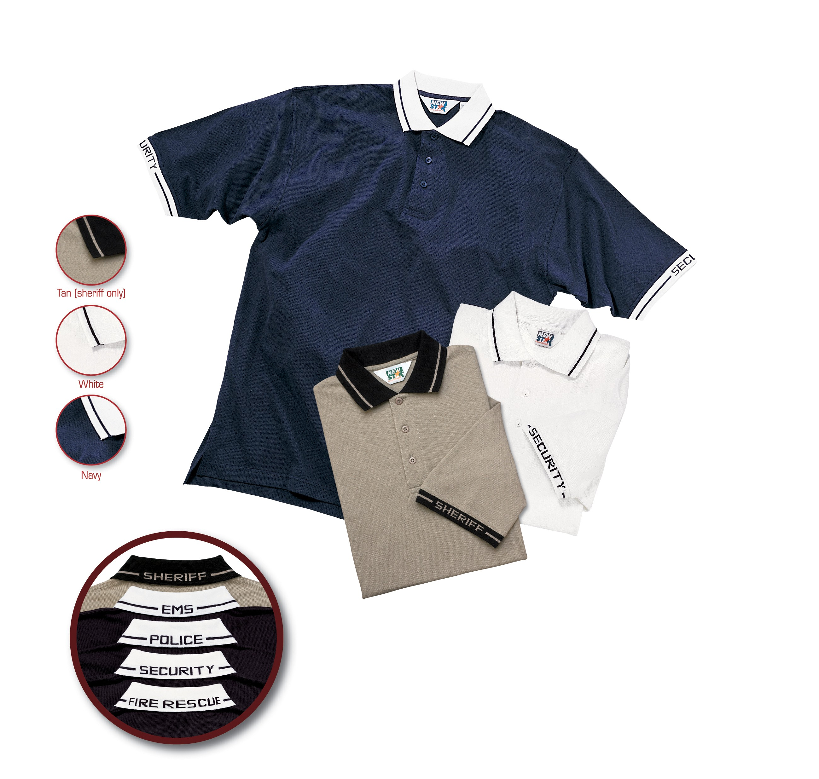

STYLE #: SECURITY POLICE EMS FIRE RESCUE

Navy 710MNV 711MNV 712MNV 713MNV

White 710MWH 711MWH - - - - - - - 713MWH

SHERIFF

Silver Tan 714MTN

STYLE: Knit shirt, pullover, heavyweight, 3-button placket front, knit collar, banded cuffs, tennis tail, side vents, “SECURITY”, or other words, knitted into the collar and sleeve bands.

FABRIC:

Contents: 100% combed cotton
Yarns: 20’s, combed
Knit: Pique
Weight: 7.0 ozs./sq. yd., 240 gms/sq. meter
Dying: Reactive dyes
Finish: Soil release

FRONT PLACKET: There shall be a 3 button placket front, averaging 7” long and 1 ½” wide. There shall be 3 matching color buttons to the body of the shirt, 4 hole with an “x” stitch. The placket shall be double stitched at the bottom. There shall be a heavy-duty interlining inside the placket.

COLLAR: There shall be a standard knit type collar. The seam attaching the collar to the body of the shirt shall be fully taped. The collar shall be white on all shirts with midnight navy lettering.

SLEEVES: There shall be a one-piece sleeve. Attached to this shall be a knitted sleeve band, 1” wide. The band shall be white on all shirts with midnight navy lettering.

SIDE VENTS & BACK TAIL: There shall be a side vent on each side of the shirt. There shall also be a longer back “tennis tail” (approximately 1-1 ½” longer)

IDENTIFICATION: The word “SECURITY” (or other words) shall be knitted into the back of the collar and on the outsides of the sleeve bands. There shall be a 5/16” wide line also knitted through the balance of both the collar and the sleeve band to complete the trim. The word “SECURITY” (or other words) shall be approximately ½” tall.

SEAMING: All armhole and shoulder joining seams shall be overlock safety stitched and then double needle topstitched with a ¼” wide stitch on the outside. The side seams shall be overlock safety stitched. There shall be a 1” wide hem at the bottom front and back. The shoulder seam shall have stay tape to prevent stretching.

THREAD: All thread shall be poly-core

FADING: The use of reactive dyes shall prevent this garment from fading for a minimum of 50 machine washings.

FINISHING: This garment shall be finished in a first class workmanlike manner with all loose threads removed. The omission or apparent omission of any wording or specifications shall mean that only the highest quality industry standards shall be used on all fabric and component parts including labor. Where there may be a discrepancy between the standard sample and the written specification, the detail of the standard sample shall prevail.

LABELS: All labels will be permanent to withstand repeated cleanings for the life of the garment. The following labels shall be applied:

MAIN LABEL: This shall identify the manufacturer either by name & location, registered trademark or WPL or RN number as required by the Federal Trade Commission.

CONTENTS/CARE/SIZE LABEL: There shall be an additional label clearly showing the fabric contents, laundering instructions and garment size.

SIZES:

 | Small | Medium | Large | X-Large | 2X-Large | 3X-Large | 4X-Large | 6X-Large
Chest: | 40 | 44 | 48 | 52 | 56 | 60 | 64 | 72
Back length: | 30.5 | 31.5 | 32.5 | 33.5 | 34.5 | 35.5 | 36.5 | 38.5
Sweep: | 39 | 43 | 47 | 51 | 55 | 59 | 63 | 71
Neck: | 15.5 | 16.5 | 17.5 | 18.5 | 19.5 | 20.5 | 21.5 | 23.5
Cuff: | 6.5 | 6.5 | 7 | 7 | 7.5 | 7.5 | 8 | 9
Shoulder: | 21.75 | 22 | 22.25 | 22.5 | 22.75 | 23 | 23.25 | 23.75
Armhole: | 22.5 | 23.5 | 24.5 | 25.5 | 26.5 | 27.5 | 28.5 | 30.5
Collar Height: | 3 | 3 | 3 | 3 | 3 | 3 | 3 | 3
Collar Point: | 3 | 3 | 3 | 3 | 3 | 3 | 3 | 3
Cuff Width: | 1 | 1 | 1 | 1 | 1 | 1 | 1 | 1
Placket length: | 7 | 7 | 7 | 7 | 7 | 7 | 7 | 7
Placket Width: | 1.5 | 1.5 | 1.5 | 1.5 | 1.5 | 1.5 | 1.5 | 1.5
Sleeve length: | 10.5 | 11 | 11.5 | 12 | 12.5 | 13 | 13.5 | 14.5
Back drop tail: | 0.75 | 0.75 | 0.75 | 0.75 | 0.75 | 0.75 | 0.75 | 0.75
Hem: | 1 | 1 | 1 | 1 | 1 | 1 | 1 | 1

