SPECIFICATIONS – EMS trouser

With expandable waistband

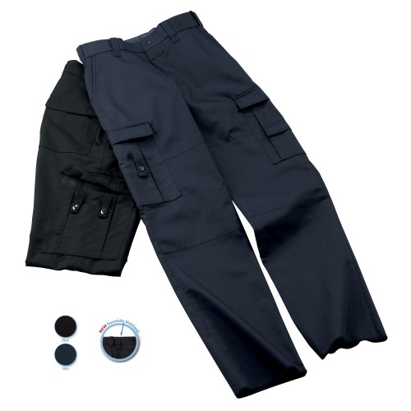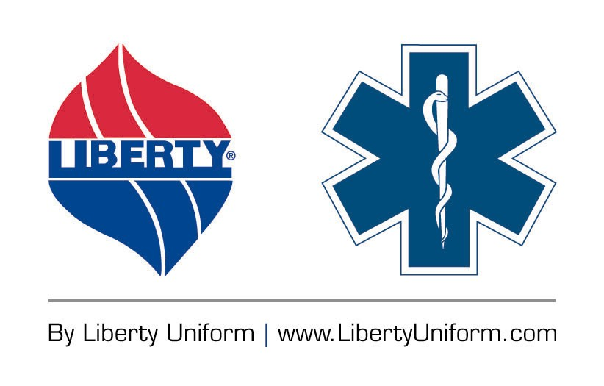

STYLE: “BDU” type trouser, two front quarter top pockets, two hip patch pockets and two side leg cargo pockets, seven belt loops, 2” waistband, Snugtex, metal button waistband closure, expandable waistband.

FABRIC:

Contents: 65% polyester, 35% cotton
Weight: 13 ozs./lin.yd.
7.8 ozs./sq. yd.
Weave: Twill
Dying: High-pressure jet dyed
Finish: LibertyGuard soil release

COLORS:
Style Gender Color
630FBK Female Black
630FNV Female Navy
630MBK Male Black
630MNV Male Navy

POCKETS: There shall be two (2) front quarter top styled pockets. The swing type pocket bag shall be 7 ½” deep. The pocket shall angle forward 1 ½ to 1 ¾” at the top. The pocket facing attached to the side seam shall be 2 ¾” wide at the top.

There shall be two (2) rear hip patch pockets with flaps. They shall be 6” wide and 6” high. The flap shall be 6” wide and 2” high. The flap shall be secured with hook & loop closure at each corner with no visible stitching in the flap. The patch pocket shall be double needle stitched on. The flap shall have double needle stitching all around. There shall be bartacks at the pocket corners.

There shall be two side cargo pockets with flaps.

The LEFT cargo pocket shall be 10” high and 7 ¼” wide. The flap shall be 2” high and 7 ¼” wide. There shall be a double needle topstitch on the flap. The flap will close with Velcro, which shall not be visible through the flap. There shall be two inverted pleats, each 1 1/8” from the side. Between these pleats, there shall be a pocket with a flap sewn onto the larger pocket. This pocket shall be 4 ¼ high and 4 ¾” wide. There will be a flap measuring 1 ½” high and 4 ¾” wide. The flap will close with Velcro, which shall not be visible through the flap.

The RIGHT cargo pocket shall be 9 ¾” high and 9” wide. The flap shall be 2” high and 9” wide. There shall be a double needle topstitch on the flap. The flap will close with Velcro, which shall not be visible through the flap. There shall be two inverted pleats, each 2” from the side. Between these pleats, there shall be a pocket sewn onto the larger pocket. This pocket shall be 6” high and 4 ¾” wide. This pocket will be divided into equal 3rds by stitching. There shall be a bartack to secure to openings of each part of the open 3rds pockets. There shall be a strap with snap closure sewn to the two outside 3rd pockets. The strap, made of shell material shall be ¾” wide. The snap cap shall be an oxidized finish – not enamel.

POCKETING: Shall be 50% polyester, 50% cotton, 260-weight drill and shall withstand all pilling for a minimum of 30 wash cycles. Color shall be black.

WAISTBAND: Shall be approximately 2” wide with rubberized Snugtex. On the outside of the waistband, along the seam where the waistband is joined to the body of the trouser, there shall be a topstitch to secure inside the curtain. There shall be a metal, jean style button at the top of the waistband for closure. A snap or hook and eye will not be an acceptable substitution.

This will be an expandable style waistband with both an inside and outside tab attached to elastic. The waistband shall expand a total of approximately 3” per garment.

BELTLOOPS: There shall be seven (7) beltloops (except 5 on sizes 28-31 male and 6 female). These shall be of shell material and interlined. They shall be bartacked on at the top. They shall extend approximately 1” below the bottom of the waistband and have both a bartack and an “X” stitch. The opening for a belt shall not be less than 2”. They shall be ¾” wide and 2 1/8” long to accommodate a 1 ¾” wide Garrison style belt. The belt loop at the side seams shall be set to the back of the side seam 5/8” to facilitate striping of needed.

DOUBLE KNEE: There shall be a double ply of shell fabric in the knee area. This shall be 10 ½” high, centered over the knee area.

ZIPPER: Shall be brass and of good commercial quality. Shall withstand all laundering and pressing for the life of the garment. Shall be self-locking style.

INSEAM: Shall be proportionally graded to average 37” open bottom.

SEAMS: Special attention shall be paid to the seam construction:
Crotch seam: Shall be double needle sewn.
Seat seam: Shall be double needle sewn.

BARTACKS: There shall be bartacks at the top and bottom of the quarter top pockets (bottom will cross the side seam), the ends of all patch pockets, the base of the fly and one bartack securing the inside of the right fly to the left fly about 1” above the bottom of the zipper. The bartack at the base of the quarter top pocket shall cross the side seam in an X format.

THREAD: All thread shall be color fast, polyester core, two-ply. This shall identically match the fabric color.

FINISHING: This garment shall be finished in a first class workmanlike manner with all loose threads removed. The omission or apparent omission of any wording or specifications shall mean that only the highest quality industry standards shall be used on all fabric and component parts including labor. Where there may be a discrepancy between the standard sample and the written specification, the detail of the standard sample shall prevail.

LABELS: All labels will be permanent to withstand repeated cleanings for the life of the garment. The following labels shall be applied:

MAIN LABEL: This shall identify the manufacturer either by name & location, registered trademark or WPL or RN number as required by the Federal Trade Commission.

CONTENTS/CARE/SIZE LABEL: There shall be an additional label clearly showing the fabric contents, laundering instructions and garment size.

SIZES:
Male: 28-38 (all sizes), 40-54 (even sizes)
Female: 6-24 (even sizes)

