SPECIFICATIONS – trousers

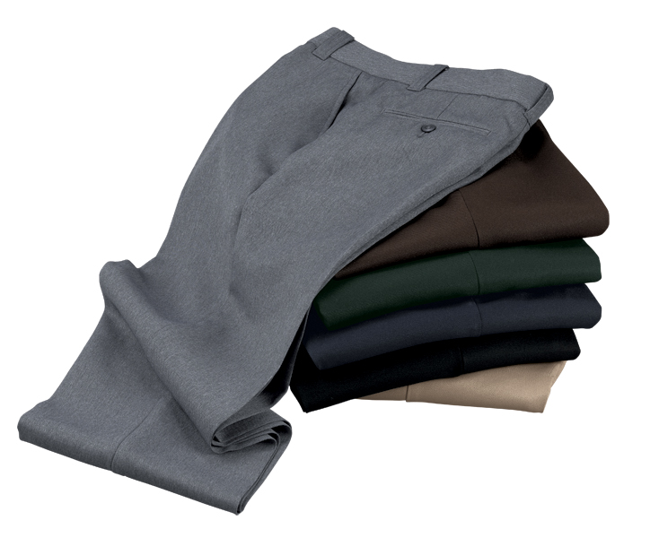

STYLE: Uniform trouser, four pockets, zipper fly front, seven beltloops, 2” waistband, Snugtex (male), Ban Rol.

FABRIC:

Contents: 100% Dacron® polyester

Construction: Warp = 64, Filling = 54

New: 69x65
Yarns: Fine, multi-filament, air jet textured, octalobal (reduces glitter)
Weave: 2x1 fine line twill
New: 2x2 twill
Elongation: two way stretch: 11% warp, 14% fill
Weight: 11-11 ½ ozs./lin.yd.
6.8 ozs./sq. yd.
New: 6.28 ozs./sq. yd.
Tear strength: Warp = 16 lbs., Fill = 14 lbs.
New: Warp = 12.1 lbs., Fill = 12.1 lbs.
Tensile strength: Warp = 100+ lbs., Fill = 100+ lbs.
New: Warp = 140 lbs., Fill = 140 lbs.
Dying: High-pressure jet dyed
Finish: Soil release

COLORS:
Male Color Female
600MBK Black 600FBK
600MBN Chocolate brown
600MGN Spruce green
600MHG Heather grey 600FHG
600MNV Midnight navy 600FNV
600MTN Silver tan

POCKETS: There shall be two (2) front quarter top styled pockets. The swing type pocket bag shall be 7 ½” deep. The pocket shall angle forward 1 ½ to 1 ¾” at the top. The pocket facing attached to the side seam shall be 2 ¾” wide at the top.

There shall be two (2) rear hip pockets. They shall be 5 ¼” wide. The left pocket shall have a button and hole closure. This shall be a Reece, double-welted style pocket. The pocket bag shall be 6” deep.

POCKETING: Shall be 50% polyester, 50% cotton, 260-weight drill and shall withstand all pilling for a minimum of 30 wash cycles. Color shall be charcoal grey.

WAISTBAND: Shall be approximately 2” wide with Snugtex (male) and Ban Rol. The female trouser shall have a shirred elastic waistband from side seam to side seam around the back. There shall be a curtain made of the same fabric and color as that of the pocketing. On the outside of the waistband, along the seam where the waistband is joined to the body of the trouser, there shall be a topstitch to secure inside the curtain.

BELTLOOPS: There shall be seven (7) beltloops (except 5 on sizes 28-31 male and 6 female). These shall be of shell material and interlined. They shall be bartacked on at the top and turned down over the bartack. There shall be tacked at the bottom. They shall be ¾” wide and 2 1/8” long to accommodate a 1 ¾” wide Garrison style belt. The belt loop at the side seams shall be set to the back of the side seam 5/8” to facilitate striping of needed.

ZIPPER: Shall be brass and of good commercial quality. Shall withstand all laundering and pressing for the life of the garment. Shall be self-locking style.

INSEAM: Shall be proportionally graded to average 37” open bottom.

SEAMS: Special attention shall be paid to the seam construction:
Leg seams: Shall be overlock safety stitched.
Sean seam: Shall be double needle sewn with a minimum 2 ½” outlet.

BARTACKS: There shall be bartacks at the top and bottom of the quarter top pockets, the ends of the hip pockets, the base of the fly and one bartack securing the inside of the right fly to the left fly about 1” above the bottom of the zipper.

THREAD: All thread shall be color fast, polyester core, two ply. This shall identically match the fabric color.

FINISHING: This garment shall be finished in a first class workmanlike manner with all loose threads removed. The omission or apparent omission of any wording or specifications shall mean that only the highest quality industry standards shall be used on all fabric and component parts including labor. Where there may be a discrepancy between the standard sample and the written specification, the detail of the standard sample shall prevail.

LABELS: All labels will be permanent to withstand repeated cleanings for the life of the garment. The following labels shall be applied:

MAIN LABEL: This shall identify the manufacturer either by name & location, registered trademark or WPL or RN number as required by the Federal Trade Commission.

CONTENTS/CARE/SIZE LABEL: There shall be an additional label clearly showing the fabric contents, laundering instructions and garment size.

SIZES:
Male: 28-38 (all sizes), 40-54 (even sizes)
Female: 4-28 (even sizes)

