SPECIFICATIONS – Zip-Out Liners #597/599

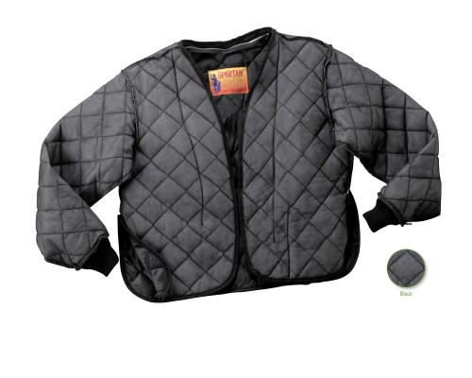

STYLE #: #597MBK - Black
#599MBK - Black

STYLE: Zip-out liner, one inside cargo pocket, zipper track to sew into open facing of
FD stationwear jacket #550 and police windbreaker 525.

FABRIC:

Face: 100% nylon taffeta

Interlining: 100% polyester fiberfill, 4.4 ozs.
Back: 100% nylon tricot

SLEEVES: Knit cuffs. There is an elastic loop at the sleeve end to secure to a button on
the inside of the windbreaker sleeve.

ZIPPER: Shall be #4 aluminum zipper, interchangeable.

