SPECIFICATIONS – ANSI Safety Vest #588MFL

5 Point Break-away

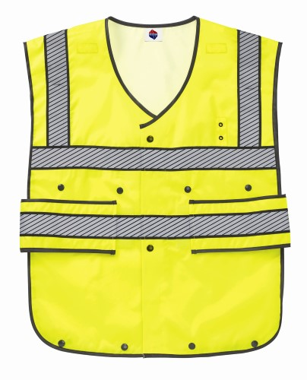

Adjustable body length Optional patches

Same color/fabric as vest

STYLE: 5 point break-away vest with hook and loop (and snap) front closure, hook and loop fastening shoulders and adjustable side tabs with hook and loop closure. Also there will be microphone tabs, badge tab, expandable length. Identity words such as POLICE for front and back are options.

FABRIC:

Shell Contents:

Yellow = 100% polyester, oxford, 150 denier with 1,000 mm white back urethane coating

ANSI 207-2006 (21” long when panels are snapped up)
ANSI 107-2010 Class 2, level 2 (28” when panels are extended)

COLORS: #588MFL – fluorescent yellow

FRONT: The front shall close with hook and loop closure with top and bottom snap. The shoulders shall attach, front to back, with hook and loop.

ADJUSTABLE TABS: There shall be two large tabs on each side of the lower portion of the vest. These shall be 4-1/4” tall and 9 ½” long. They shall have reflective tape on them. They shall close to the front of each side with fluorescent yellow Velcro placed on the under side of each tab and horizontally along the front of the vest to adjust the sizing.

Then entire vest shall be bound with black nylon binding.

ADJUSTABLE BODY LENGTH: The length of each vest shall be 21” long. There shall be a drop down panel, front and back, of shell material to extend the length to 28” long. These shall be held in place by plastic snaps.

REFLECTIVE FABRIC: There shall be 2” wide silver reflective fabric sewn on. There shall be black fabric trimming along all edges of the silver reflective tape.
- Around the upper chest
- Around the lower body
- Over each shoulder from the upper tape front & back.

NOTE: distance between shoulder stripes on the back of the vest shall be a minimum of 13” apart to allow for a 12” silk screen between them.

BADGE TAB: There shall be badge tab with metal eyelets affixed to the left chest. The eyelets shall be spaced 1 ¼” apart.

MICROPHONE LOOPS: There shall be a microphone loop approximately 3” below the shoulder on each front panel. These shall be made of a double ply of shell material. They shall be 2” wide (left to right) and ¾” tall.

PENCIL OPENINGS: There shall be an opening in the upper portion of each shoulder reflective tape to accommodate a pen. The opening shall be made with a stitched border.

SHOULDER BREAK-AWAY: The shoulders shall attach front to back with Velcro.

FINISHING: This garment shall be finished in a first class workmanlike manner with all loose threads removed. The omission or apparent omission of any wording or specifications shall mean that only the highest quality industry standards shall be used on all fabric and component parts including labor. Where there may be a discrepancy between the standard sample and the written specification, the detail of the standard sample shall prevail.

LABELS: All labels will be permanent to withstand repeated cleanings for the life of the garment. The following labels shall be applied:

MAIN LABEL: This shall identify the manufacturer either by name & location, registered trademark or WPL or RN number as required by the Federal Trade Commission.

CONTENTS/CARE/SIZE LABEL: There shall be an additional label clearly showing the fabric contents, laundering instructions and garment size.

SIZES:
Label -> | SM-MD | LG-XL | 2X-3X
For chest sizes | 36-42 | 44-50 | 52-58

