SPECIFICATIONS – Reversible Rain Jacket #587MFL

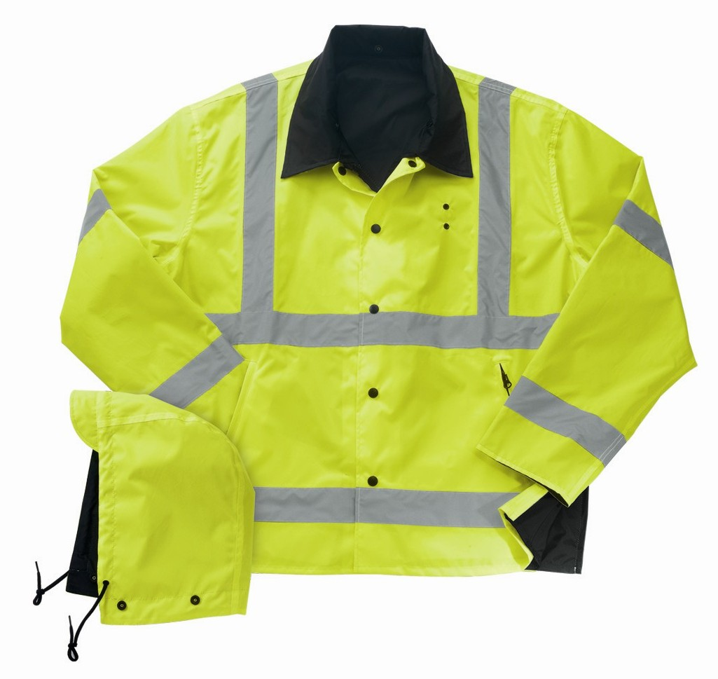
STYLE: Reversible, zipper front with outside & inside storm fly, removable hood with visor, badge eyelets, two slash zipper front pockets with welt cover, waterproof zipper side vents, reflective tape, 30” average length.

FABRIC:

Shell Contents:

Yellow = 100% polyester, oxford, 150 denier with 1,000 mm white back urethane coating
Black = 100% polyester, oxford, 150 denier with 600 mm clear back urethane coating
ANSI/ISEA 107-2004 Class 3 compliant

COLORS: #587MFL – black reversing to fluorescent yellow (with reflective tape)

FRONT: Five (5) plastic, heavy duty front snap closure, black, with both inside and outside storm flys.

REFLECTIVE FABRIC: There shall be 2” wide silver reflective fabric sewn on and seam sealed as follows onto the yellow side:
- Around the chest
- Around the upper arm aligned with chest tape
- Around the waist
- Around the sleeves aligned with the waist tape
- Over each shoulder beginning at the top of the front chest tape, over the shoulder and ending at the top of the back chest tape.

BADGE TAB: There shall be badge eyelets affixed to the left breast. They shall be spaced 1 ¼” apart.

POCKETS: There shall be two (2) slash pockets with a hidden waterproof coil zipper underneath on each side. They shall be 7” long. Pocketing shall be made of shell material for extra strength.

There shall be one chest pocket on the black side with a flap. This shall be 4-1/2” wide and 6” tall. The flap shall be 4-1/2” wide and 2” tall. There shall be a center piece of Velcro to close the pocket flap. The flap shall be interlined with non-woven material to add body.

COLLAR: There shall be shirt style collar made of shell material. The color on each side shall be black.

SLEEVES: Shall be one piece, set-in style. There shall be snaps at the end of the sleeve to adjust the opening of the sleeve.

HOOD: There shall be a removable, reversible hood with a visor and draw cord with cord locks.

SIDE VENTS: There shall be waterproof zippered side vents for weapon access. These shall average 15” long. There will be a strap with snap at the bottom of each side vent to secure the back panel to the front panel when the zipper is in the open (up) position.

AIR VENTS: There shall be three (3) eyelet holes under the arm pits for breath ability.

SEWING/SEAMS: Seams on the black side shall be lap seams, double stitched. Seams on the Fluorescent side shall be single needle stitched and taped (seam sealed) to be 100% waterproof.

FINISHING: This garment shall be finished in a first class workmanlike manner with all loose threads removed. The omission or apparent omission of any wording or specifications shall mean that only the highest quality industry standards shall be used on all fabric and component parts including labor. Where there may be a discrepancy between the standard sample and the written specification, the detail of the standard sample shall prevail.

LABELS: All labels will be permanent to withstand repeated cleanings for the life of the garment. The following labels shall be applied:

MAIN LABEL: This shall identify the manufacturer either by name & location, registered trademark or WPL or RN number as required by the Federal Trade Commission.

CONTENTS/CARE/SIZE LABEL: There shall be an additional label clearly showing the fabric contents, laundering instructions and garment size.

SIZES:
 | XS | SM | MD | LG | XL | 2X | 3X | 4X | 6X
Chest -> | 30-32 | 34-36 | 38-40 | 42-44 | 46-48 | 50-52 | 54-56 | 58-60 | 66-68
Sleeve -> | 35 | 36 | 37 | 38 | 39 | 40 | 41 | 42 | 44

