SPECIFICATION

Job Shirt #577MNV

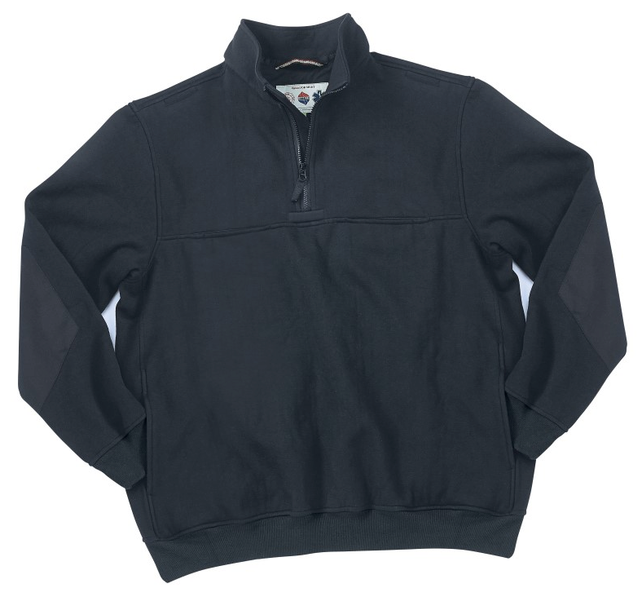

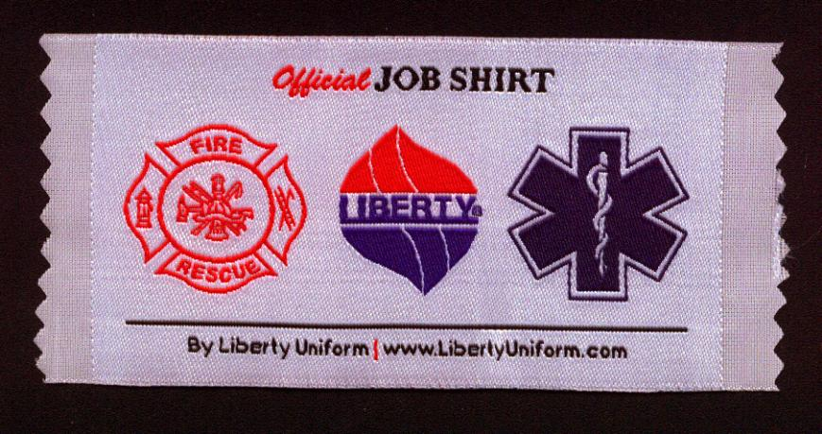

STYLE #: #577MNV - Navy

STYLE: Half zip front, pullover sweat shirt, zip to top of collar, elbow patch, pencil pocket, zipper side vents

FABRIC:

Contents: 85% cotton, 15% polyester

Weave: Fleece
Knit: 1x1 rib for waistband & cuffs
Weight: 11.5 ozs. per sq. yd.
Dying process: Reactive dying for maximum color retention
Finish: NanoTex® water & stain repellant finish.

FRONT: There shall be a ¼ zipper front opening to the top of the collar. The zipper shall begin at a horizontal seam across the center of the chest. This shall be a #5 nylon Vison zipper with a cloth pull tab on the slider. There shall be an inside storm fly behind the full length of the zipper made of shell material.

COLLAR: The collar shall be a stand up style made of shell material. The zipper shall finish ¼” below the top of the collar. There shall be an inside storm fly of shell material. This shall extend to the top of the collar (1/4” above the top of the zipper. The zipper shall be a #5 Vislon zipper. It shall have a cloth tab on the zipper pull.

POCKETS: All chest pocket bags shall be made of 65% polyester/35% cotton twill to match the elbow patches. They shall be sewn with an overlock, safety stitch seam.

CHEST POCKETS: There shall be a horizontal pocket on the left and right chest set into the horizontal chest seam. Each shall measure 6-1/4” wide and 9” deep. There shall be a bartack on each side of the top opening. Each shall have a hidden zipper top closure using a #3 nylon coil zipper. There shall also be a strip of Velcro 2” wide and ½” high at the inside top edge of the pocket opening, just below the zipper. On inside bottom of the hanging pocket bag, there shall be two Velcro tabs, each 1” wide and ½” high. They shall be set 1” from each pocket edge in a straight line and 2-1/4” above the bottom of the pocket bag. This will effectively shorten the pocket unless the Velcro is opened, allowing for the placement of a radio. On the outer edge of each chest pocket there shall be a patch to make up an inside cell phone pocket measuring 4-1/4” wide and 5” deep. It will be set 1” below the zipper at the top. All inside pockets shall have corner bartacks at the top opening. Pocket bags to be made of twill or twill material to match elbow patches.

PENCIL POCKET: On the front left chest, above the horizontal pocket, there shall be a small pencil pocket, 1-1/2” wide with a single welt of shell material.

SIDE SEAM HAND POCKETS: There shall be an on-seam hand pocket on the left and right side seams. They shell begin 2” above the knit waistband. The opening shall be 6”. They shall be made of shell material. There shall be a bartack at each end of the pocket opening. The inside of the pocket shall extend to the waistband seam. Pocket bag to be of shell fleece material. There shall be a “D” ring inside the right pocket for key attachment.

MICROPHONE ATTACHMENT POCKETS: There shall be a small microphone pocket set into both the left and right shoulder seams. These shall measure 2” wide and 3” deep. The pocket bag shall be made of twill material. There shall be a single welt across the top of the opening made of twill material. There shall be a bartack at each side. These pockets shall begin 1-3/4” from the armhole seam.

LOOP TAB: There shall be a short loop placed horizontally across the bottom of the chest zipper at the horizontal chest seam. It shall measure 1-1/4” wide and 3/8” high. It shall be made of twill material. There shall be a bartack at each end.

PATCHES: There shall be elbow patches of a polyester/cotton twill material of a coordinating color to the sweatshirt. These shall average 6” wide and 9” long.

SLEEVES: There shall be a one-piece sleeve, set-in style. The sleeve inseam shall be overlock stitching. The armhole seam shall be overlock stitch on the inside with a ¼” top stitch around the armhole.

WAISTBAND: There shall be a separate knit waistband, 2-1/2” tall. This shall be a 1x1 rib of a material perfectly matching the shell material.

WRISTLETS: There shall be knit wristlets, 2-1/2” tall. This shall be a 1x1 rib of a material perfectly matching the shell material.

WIRE PASS THROUGH OPENING: There shall be a 1-1/2” wire pass through opening on both left and right side seams just above the pocket openings allowing a radio wide to pass through.

SEAMING: All seams shall be overlock safety stitched. There shall be a ¼” top stitch on the shoulder, armhole, side seams and collar.

THREAD: All thread shall be poly-core, cotton wrapped and color fast.

FINISHING: This garment shall be finished in a first class workmanlike manner with all loose threads removed. The omission or apparent omission of any wording or specifications shall mean that only the highest quality industry standards shall be used on all fabric and component parts including labor. Where there may be a discrepancy between the standard sample and the written specification, the detail of the standard sample shall prevail.

LABELS: There shall be a half moon piece of twill fabric at the top inside back of the sweatshirt where all labels shall be sewn. This shall measure 6-1/2” wide and 4-1/2” tall.

All labels will be permanent to withstand repeated cleanings for the life of the garment. The following labels shall be applied:

MAIN LABEL: This shall identify the manufacturer either by name & location, registered trademark or WPL or RN number as required by the Federal Trade Commission.

CONTENTS/CARE/SIZE LABEL: There shall be an additional label clearly showing the fabric contents, laundering instructions and garment size.

LOCKER LOOP: There shall be a locker loop on the inside back of the neck seam.

SIZES: XS – 4X and 6X

