**#575MFL ANSI-3, THREE SEASON JACKET**

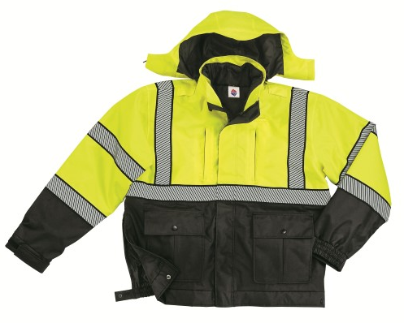

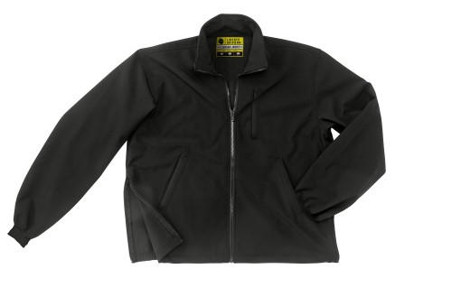 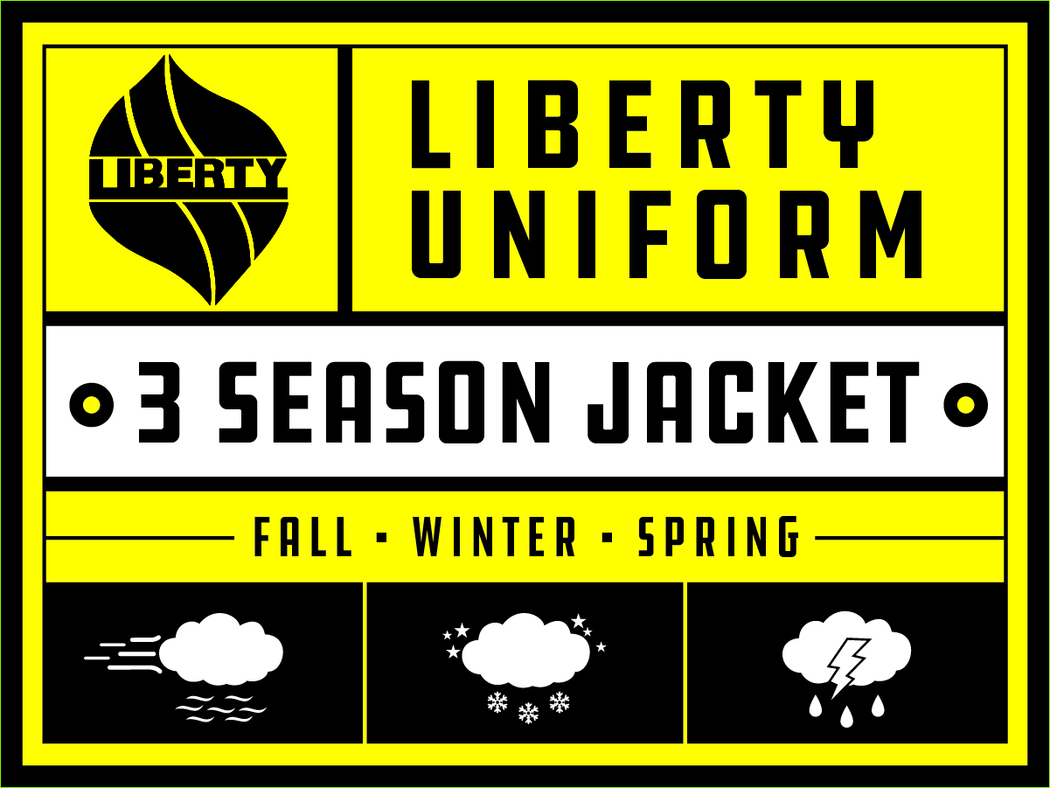 \

**Inside SOFT SHELL jacket/liner Main label for both shell and liner**

**STYLE:**

1. Average 29” (size LG).
2. Zipper front to top of collar
3. Outside storm fly with Velcro closure (4-5 spots), over zipper
4. Zip-out liner is also a self-closing jacket.
5. Hidden, unlined, pop-out hood.
6. Segmented silver reflective tape per diagram.

**MATERIAL:**

**OUTER JACKET:**

SHELL:

1. **ANSI 3 compliant**
2. 100% nylon oxford with waterproof back coating
3. Seam sealed – waterproof and windproof
4. Upper front = fluorescent yellow
5. Lower front = black
6. Lower sleeves = black all around
7. Back = fluorescent yellow

LINING:

1. 100% nylon

**INNER ZIP-OUT LINER JACKET:**

SHELL:

1. Soft shell, 100% polyester, 4-way stretch, waterproof/breathable membrane, windproof
2. Black

**DESIGN DETAILS:**

**OUTER JACKET:**

1. Zipper front to top of collar, Vislon, #5, black
2. Outside storm fly with Velcro closure.
3. Two lower 2-way pockets with center inverted pleat. Straight bottom flap, mitered corners, Velcro closure under each side. Side opening hand warmer pockets lined with fleece material on top side.
4. Two upper vertical, welt storage pockets. Opening to be 6-1/2” wide. Welt cover to be ¾”. Hidden zipper to be nylon coil #5, black. Bar-tack top & bottom of welts.
5. One left chest welt pen pocket, 1-1/2” wide and 5” deep.
6. One inside horizontal set-in pocket
7. Zipper side vents (11” tall), #5 nylon coil zipper, black. There will be a tab & snap closure at the bottom of the side vents.
8. Elasticized cuffs with Velcro tab closure.
9. Microphone loops at shoulder on each side.
10. Hood with visor & draw cord. There will be a zipper under the collar and the hood will drop down inside the jacket between the shell and the lining.
11. Waistband to be shirred elastic around back.

**INNER LINER JACKET:**

1. Inside liner becomes a self-wearing jacket. Zippers shall coordinate with a zipper inside each side of the shell jacket. There shall be a loop at the back of the neck. This shall secure to a tab & snap inside the neck of the shell jacket.
2. Zipper front to top of collar, coil, #5, black
3. Two lower side seam slash welt pockets.
4. One upper vertical left chest pocket
5. Bottom shall be straight hem, no knit waistband. Back will be shirred elastic.
6. Zippered side vents (11”) to coordinate with zipper side vents on main jacket.
7. There will be a tab and snap closure at the bottom of the side vent zippers.
8. 2-1/2” wide cuff made of shell fleece material.

**REFLECTIVE TAPE:**

There shall be segmented silver reflective tape on the yellow shell jacket as follows:

* Around upper chest
* Around lower body
* Around upper sleeves
* Around lower sleeves
* Over each shoulder from/to the upper chest

**SIZES:**

XS to 4X and 6X