SPECIFICATIONS – Security Parka

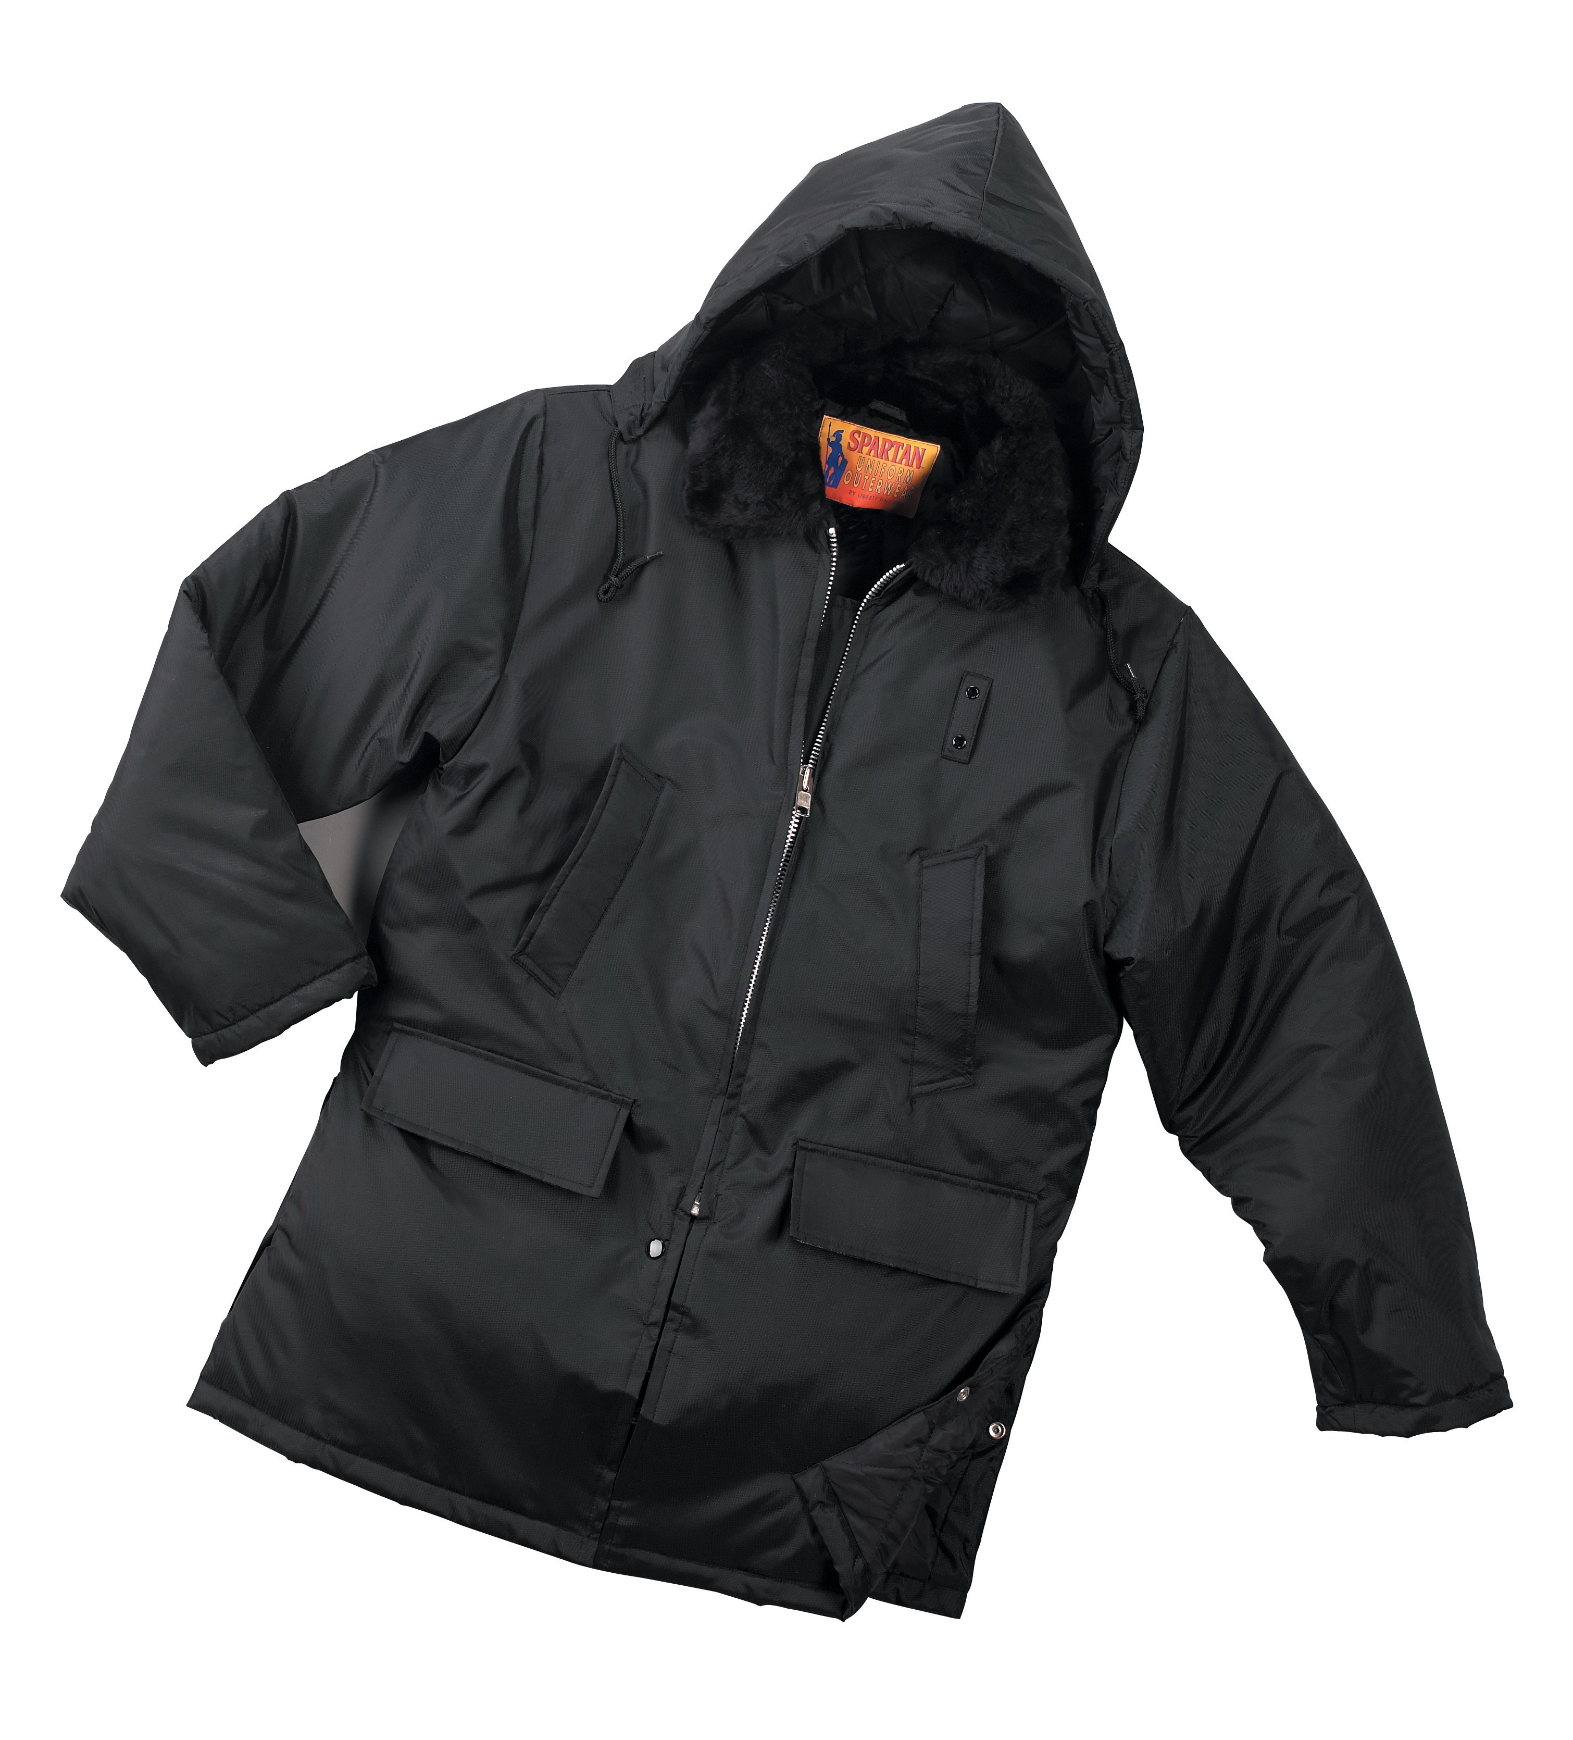
STYLE: Zipper front with inside storm fly, pile collar, quilt lined, two (2) upper slash pockets, two (2) lower set-in flap pockets, side vents with snaps, zip-off quilted hood with drawcord, inside knit cuffs, drawcord at waist, badge tab, 34” average length.

FABRIC:

Shell Contents: 100% polyester (full-dull)

Denier: 200 x 200 (yarn size)
Yarns: singles
Weave: Oxford
Dying: High-pressure jet dyed
Finish: Acrylic back coating & DWR face

Lining contents: Face = 100% nylon taffeta, 68 pick
Quilt = 100% polyester fiberfill, 7.5 ozs.
Stitch = 6” diamond
Collar: 100% acrylic
Knit cuffs: 100% acrylic

COLORS: #568MBK – Black
#568MBN – Brown
#568MVN – Navy blue

FRONT: FRONT: There shall be a heavy-duty #8 heavy-duty black plastic molded non-freeze zipper front with inside storm fly. A cord shall be inserted inside both fabric lips covering the zipper to assure that the slider does not catch on the fabric. There will be a snap through the front and fly under the zipper.

BADGE TAB: There shall be a badge tab affixed to the left breast made of shell material. This shall be small metal eyelets spaced 1 ¼” apart.

POCKETS: There shall be two (2) upper slash, single welt pockets. They shall be 7” long with a 1 ¾” wide welt. There shall be two (2) lower set-in welt pockets with a flap. The flap shall be 7” wide and 3” high. The pocket shall be about 7 ½” deep. There will be bar-tacks at the corners of all pockets. Pocketing shall be made of shell material for extra strength or 50% polyester, 50% cotton drill.

COLLAR: There shall be a permanent pile collar of matching color to the color of the jacket. This shall be “seal skin” quality, 24 oz. acrylic. The under collar shall be of shell material with a heavy non-woven interlining.

HOOD: There shall be a two-piece, quilt lined zip-off hood with a drawcord. Zipper shall be 7” aluminum.

DRAWCORD: There shall be a drawcord at the waist secured by a “tunnel”. This shall exit through sewn buttonholes on the inside facing.

SLEEVES: Shall be one piece, set in style. There shall be an inside knit wristlet finishing 2 ¾” of 100% acrylic, 1x1 rib.

SIDE VENTS: There will be side vents approximately 11” high. There will be a snap to secure just below the center.

SEWING/SEAMS: All main shell seams shall be overlock safety stitched. All remaining joining seams shall be chain stitched.

BARTACKS: There shall be bartacks on both sides of the base of the zipper and at the ends of each pocket welt.

THREAD: All thread shall be 3-ply, #50, poly-core thread, vat dyed.

INTERLININGS: The pocket welts, storm fly, waistband (between the knit and front edge) and collar shall be interlined with a heavy non-woven material.

FINISHING: This garment shall be finished in a first class workmanlike manner with all loose threads removed. The omission or apparent omission of any wording or specifications shall mean that only the highest quality industry standards shall be used on all fabric and component parts including labor. Where there may be a discrepancy between the standard sample and the written specification, the detail of the standard sample shall prevail.

LABELS: All labels will be permanent to withstand repeated cleanings for the life of the garment. The following labels shall be applied:

MAIN LABEL: This shall identify the manufacturer either by name & location, registered trademark or WPL or RN number as required by the Federal Trade Commission.

CONTENTS/CARE/SIZE LABEL: There shall be an additional label clearly showing the fabric contents, laundering instructions and garment size.

SIZES:
 | SM | MD | LG | XL | 2X | 3X | 4X | 6X
Chest -> | 34-36 | 38-40 | 42-44 | 46-48 | 50-52 | 54-56 | 58-60 | 66-68
Sleeve -> | 35 | 36 | 37 | 38 | 39 | 40 | 41 | 43

