SPECIFICATIONS – ANSI 3

Polar Parka

Style #566MFL

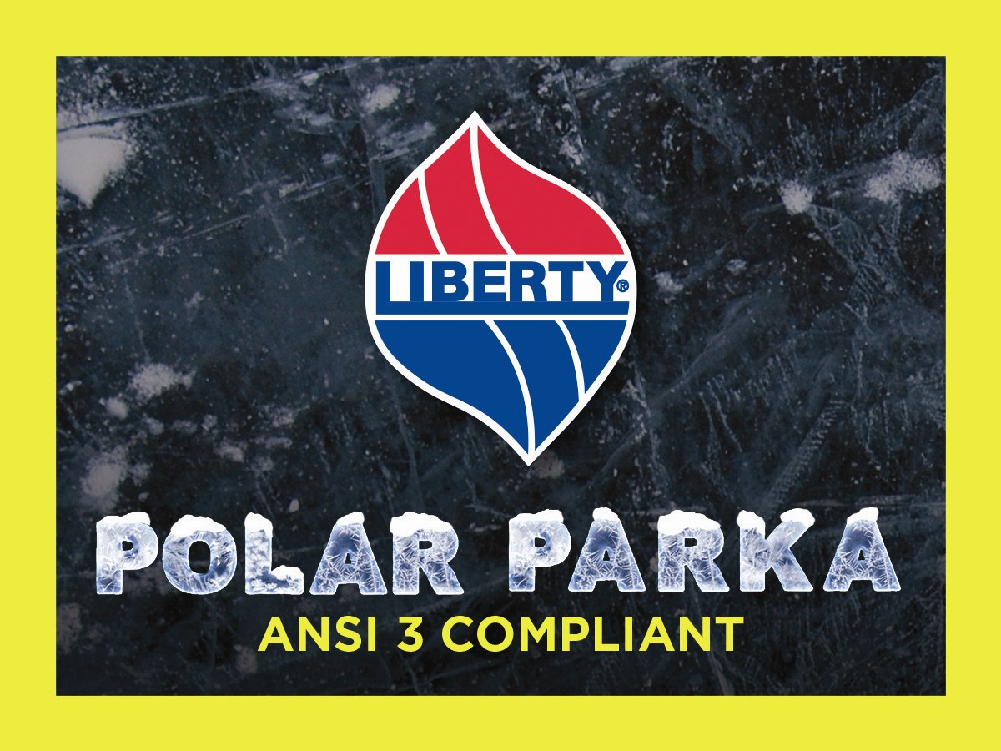

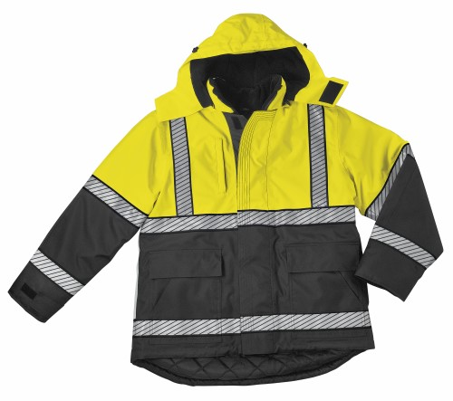

STYLE: ANSI 3 compliant, reflective tape, zipper front to top of collar with both inside and outside storm fly, Polar Fleece collar lining, quilt lined sleeves and lower body, fleece lined upper body with polyester fiberfill backing, two (2) slash 2-way lower cargo pockets with flaps, one outside vertical zippered chest pocket, one outside radio pocket, one inside zippered cargo pocket, microphone tabs, supplied badge tab, zip-off quilted hood with drawcord, inside knit cuffs, full elasticized inside apron with snap closure, kidney extension, 34” average length.

FABRIC:

Shell Contents: 100% polyester (full-dull)

Denier: 300 x 300 (yarn size)
Yarns: singles
Weave: Oxford
Dying: High-pressure jet dyed
Finish: Polyurethane back coating & DWR face
Waterproof (sealed seams) and breathable

Lining contents:
Lower body & sleeves = 100% nylon taffeta, 68 pick
Quilt = 100% polyester fiberfill, 7.5 ozs.

Upper body front & back = 100% polyester fleece
Quilt = 100% polyester fiberfill, 7.5 ozs.

Collar Lining: Polar fleece
Knit cuffs: 100% acrylic

COLORS: #566MFL – Fluorescent yellow

FRONT: There shall be a Vislon #5 heavy black plastic molded non-freeze zipper front with both inside and outside storm fly. Zipped shall extend to the top of the collar. Outside fly shall close with Velcro to the inside flies.

BACK: The back shall extend 3” lower than the front to act as a kidney protector.

REFLECTIVE TAPE: This ANSI 3 compliant parka shall have segmented silver reflective tape around the upper chest and lower body. There shall be one strip on each front from the upper reflective tape, over the shoulder to the upper reflective tape on the back side. There shall be an upper and lower strip on each sleeve.

POCKETS: There shall be two (2) lower 2-way patch pockets with flaps. They shall be 10” high with a 3-1/4” high flap. There will be bar-tacks at the corners of all pockets. Pockets shall be made of shell material. There shall be one vertical zippered, welted pocket on the left chest. The welt shall measure 6-1/4” x ¾”. There shall be one radio pocket with flap on the right chest. This shall be a bellows style with expandable sizes & bottom. It shall be 8” tall and 3” wide. The bellows shall expand 2-1/2”. The pocket flap shall be 5” long and 3-1/2” wide and secured with Velcro.

COLLAR: There shall be a permanent stand up self-goods collar of matching color to the color of the jacket. The inside of the collar shall be black Polar Fleece.

HOOD: There shall be a three piece, fleece lined zip-off hood with a drawcord. Zipper shall be a #5 black coil. There shall be a built in visor to the hood.

WAIST APRON: There shall be an inside elasticized apron (cummerbund) made of nylon material with extended tabs at either end. This shall keep the wind out when closed. It shall measure 4” in height and shall be the full circumference of the jacket.

SLEEVES: Shall be one piece, set in style. There shall be an inside knit wristlet finishing 2” of 100% acrylic, 1x1 rib. There shall be an adjustable tab with Velcro on each sleeve cuff to adjust for tightness if desired.

MICROPHONE TABS: There shall be a microphone tab at the top of both the left and right front chest, about 3” below the shoulder seam. These shall be 2-1/2” wide and ½” tall, and bartacked at each end. They shall align with the top of the front fly. They shall be made of yellow shell material.

BADGE TAB: There shall be a supplied (but not sewn on) badge tab with each parka. This shall be 2-1/4” tall and ¾” wide. There shall be two horizontal buttonholes spaced 1-1/4” apart and centered. It shall be made of yellow shell material.

SEWING / SEAMS: All main shell seams shall be overlock safety stitched. All remaining joining seams shall be chain stitched. All inside seams shall be taped for waterproof finish.

BARTACKS: There shall be bartacks on both sides of the base of the zipper and at the ends of each pocket welt.

THREAD: All thread shall be 3-ply, #50, poly-core thread, vat dyed.

FINISHING: This garment shall be finished in a first class workmanlike manner with all loose threads removed. The omission or apparent omission of any wording or specifications shall mean that only the highest quality industry standards shall be used on all fabric and component parts including labor. Where there may be a discrepancy between the standard sample and the written specification, the detail of the standard sample shall prevail.

LABELS: All labels will be permanent to withstand repeated cleanings for the life of the garment. The following labels shall be applied:

MAIN LABEL: This shall identify the manufacturer either by name & location, registered trademark or WPL or RN number as required by the Federal Trade Commission.

CONTENTS/CARE/SIZE LABEL: There shall be an additional label clearly showing the fabric contents, laundering instructions and garment size.

SIZES:
 | SM | MD | LG | XL | 2X | 3X | 4X | 6X
Chest -> | 34-36 | 38-40 | 42-44 | 46-48 | 50-52 | 54-56 | 58-60 | 66-68
Sleeve -> | 34.5 | 35.5 | 36.5 | 37.5 | 38.5 | 39.5 | 40.5 | 42.5

