SPECIFICATION – Hi-Vis windbreaker #561
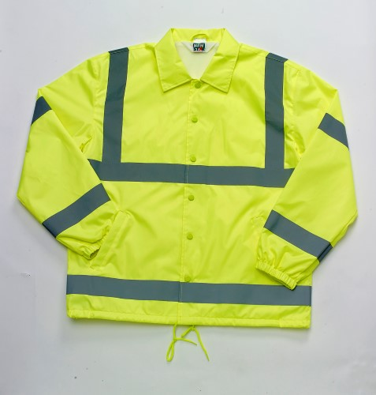

COLOR #: #561MFL – Fluorescent yellow

STYLE: Snap front jacket, fully lined, drawstring bottom, elasticized cuffs, two slash pockets, set-in sleeves, shirt style collar, silver reflective tape

FABRIC:

SHELL:

Contents: 100% polyester (for strength and better color retention)
Weave: Taffeta, 70 denier
Finish: Polyurethane or acrylic back coated for wind and water resistance.

LINING: 100% polyester brushed tricot

FRONT CLOSURE: Shall close with six (6) snaps. Enamel of cap shall match the color of the jacket.

INSIDE FACING: There shall be an inside facing made of shell material between the front edge and the lining material. This shall be 1-1/4” wide beginning at the bottom and continuing to the second snap from the top. Then it shall angle wider toward the collar seam. Along the collar seam it shall be 4” wide.

LINING: The jacket shall have a permanent, full lining of 100% polyester, brushed tricot. Material is reversed to back side inside the sleeves.

POCKETS:
There shall be two (2) set-in welt style pockets. The welts shall measure 7” long and 1” wide secured with a bartack at each end. The pocket bag shall be made of the same material as the lining. The color of the bag shall be white.

COLLAR: The collar shall be a pointed, shirt style collar of shell material. This shall be fully interlined.

SLEEVES & CUFFS: There shall be a one-piece set-in sleeve. Each sleeve will have a 1/32” topstitch encircling the armhole. There will be an elasticized cuff on each sleeve.

DRAWSTING: There shall be a drawstring closure in the bottom hem of the jacket. The color shall match that of the jacket.

REFLECTIVE TAPE: There shall be 2” wide silver reflective tape around the upper chest, lower waist, upper arm, lower sleeve and over the shoulders from the upper chest tape.

LOCKER LOOP: There shall be a locker loop made of shell material at the neck seam.

SEAMING: All main joining seams shall be overlock safety stitched. The armhole seam and the top shoulder shall be topstitched with a 1 32” stitch on the outside to secure in place.

THREAD: All thread shall be poly-core. All main seams shall use a #50 thread and the balance #60.

BARTACKS: All pocket corners shall be properly bartacked.

FINISHING: This garment shall be finished in a first class workmanlike manner with all loose threads removed. The omission or apparent omission of any wording or specifications shall mean that only the highest quality industry standards shall be used on all fabric and component parts including labor. Where there may be a discrepancy between the standard sample and the written specification, the detail of the standard sample shall prevail.

LABELS: All labels will be permanent to withstand repeated cleanings for the life of the garment. The following labels shall be applied:

MAIN LABEL: There shall be a main label on the jacket. This shall identify the manufacturer either by name & location, registered trademark, WPL or RN number as required by the Federal Trade Commission.

CONTENTS/CARE/SIZE LABEL: There shall be an additional label on both the jacket clearly showing the fabric contents, laundering instructions and garment size.

NAME LABEL: There shall be a label to write one’s name on the inside facing of the jacket.

PATTERN & SIZING: The pattern of this garment shall be an oversized pattern with the following measurements:

 |  |  | Back
Size | Chest | Sleeve | Length | Neck
Small (34-36) | 44 | 35 | 28.5 | 18
Medium (38-40) | 48 | 36 | 29 | 19
Large (42-44) | 52 | 37 | 29.5 | 20
X-Large (46-48) | 56 | 38 | 30 | 21
2X-Large (50-52) | 60 | 39 | 30.5 | 22
3X-Large (54-56) | 64 | 40 | 31 | 23
4X-Large (58-60) | 68 | 41 | 31.5 | 24
6X-Large (66-68) | 76 | 43 | 32.5 | 26

