SPECIFICATIONS – FD Station wear Jacket

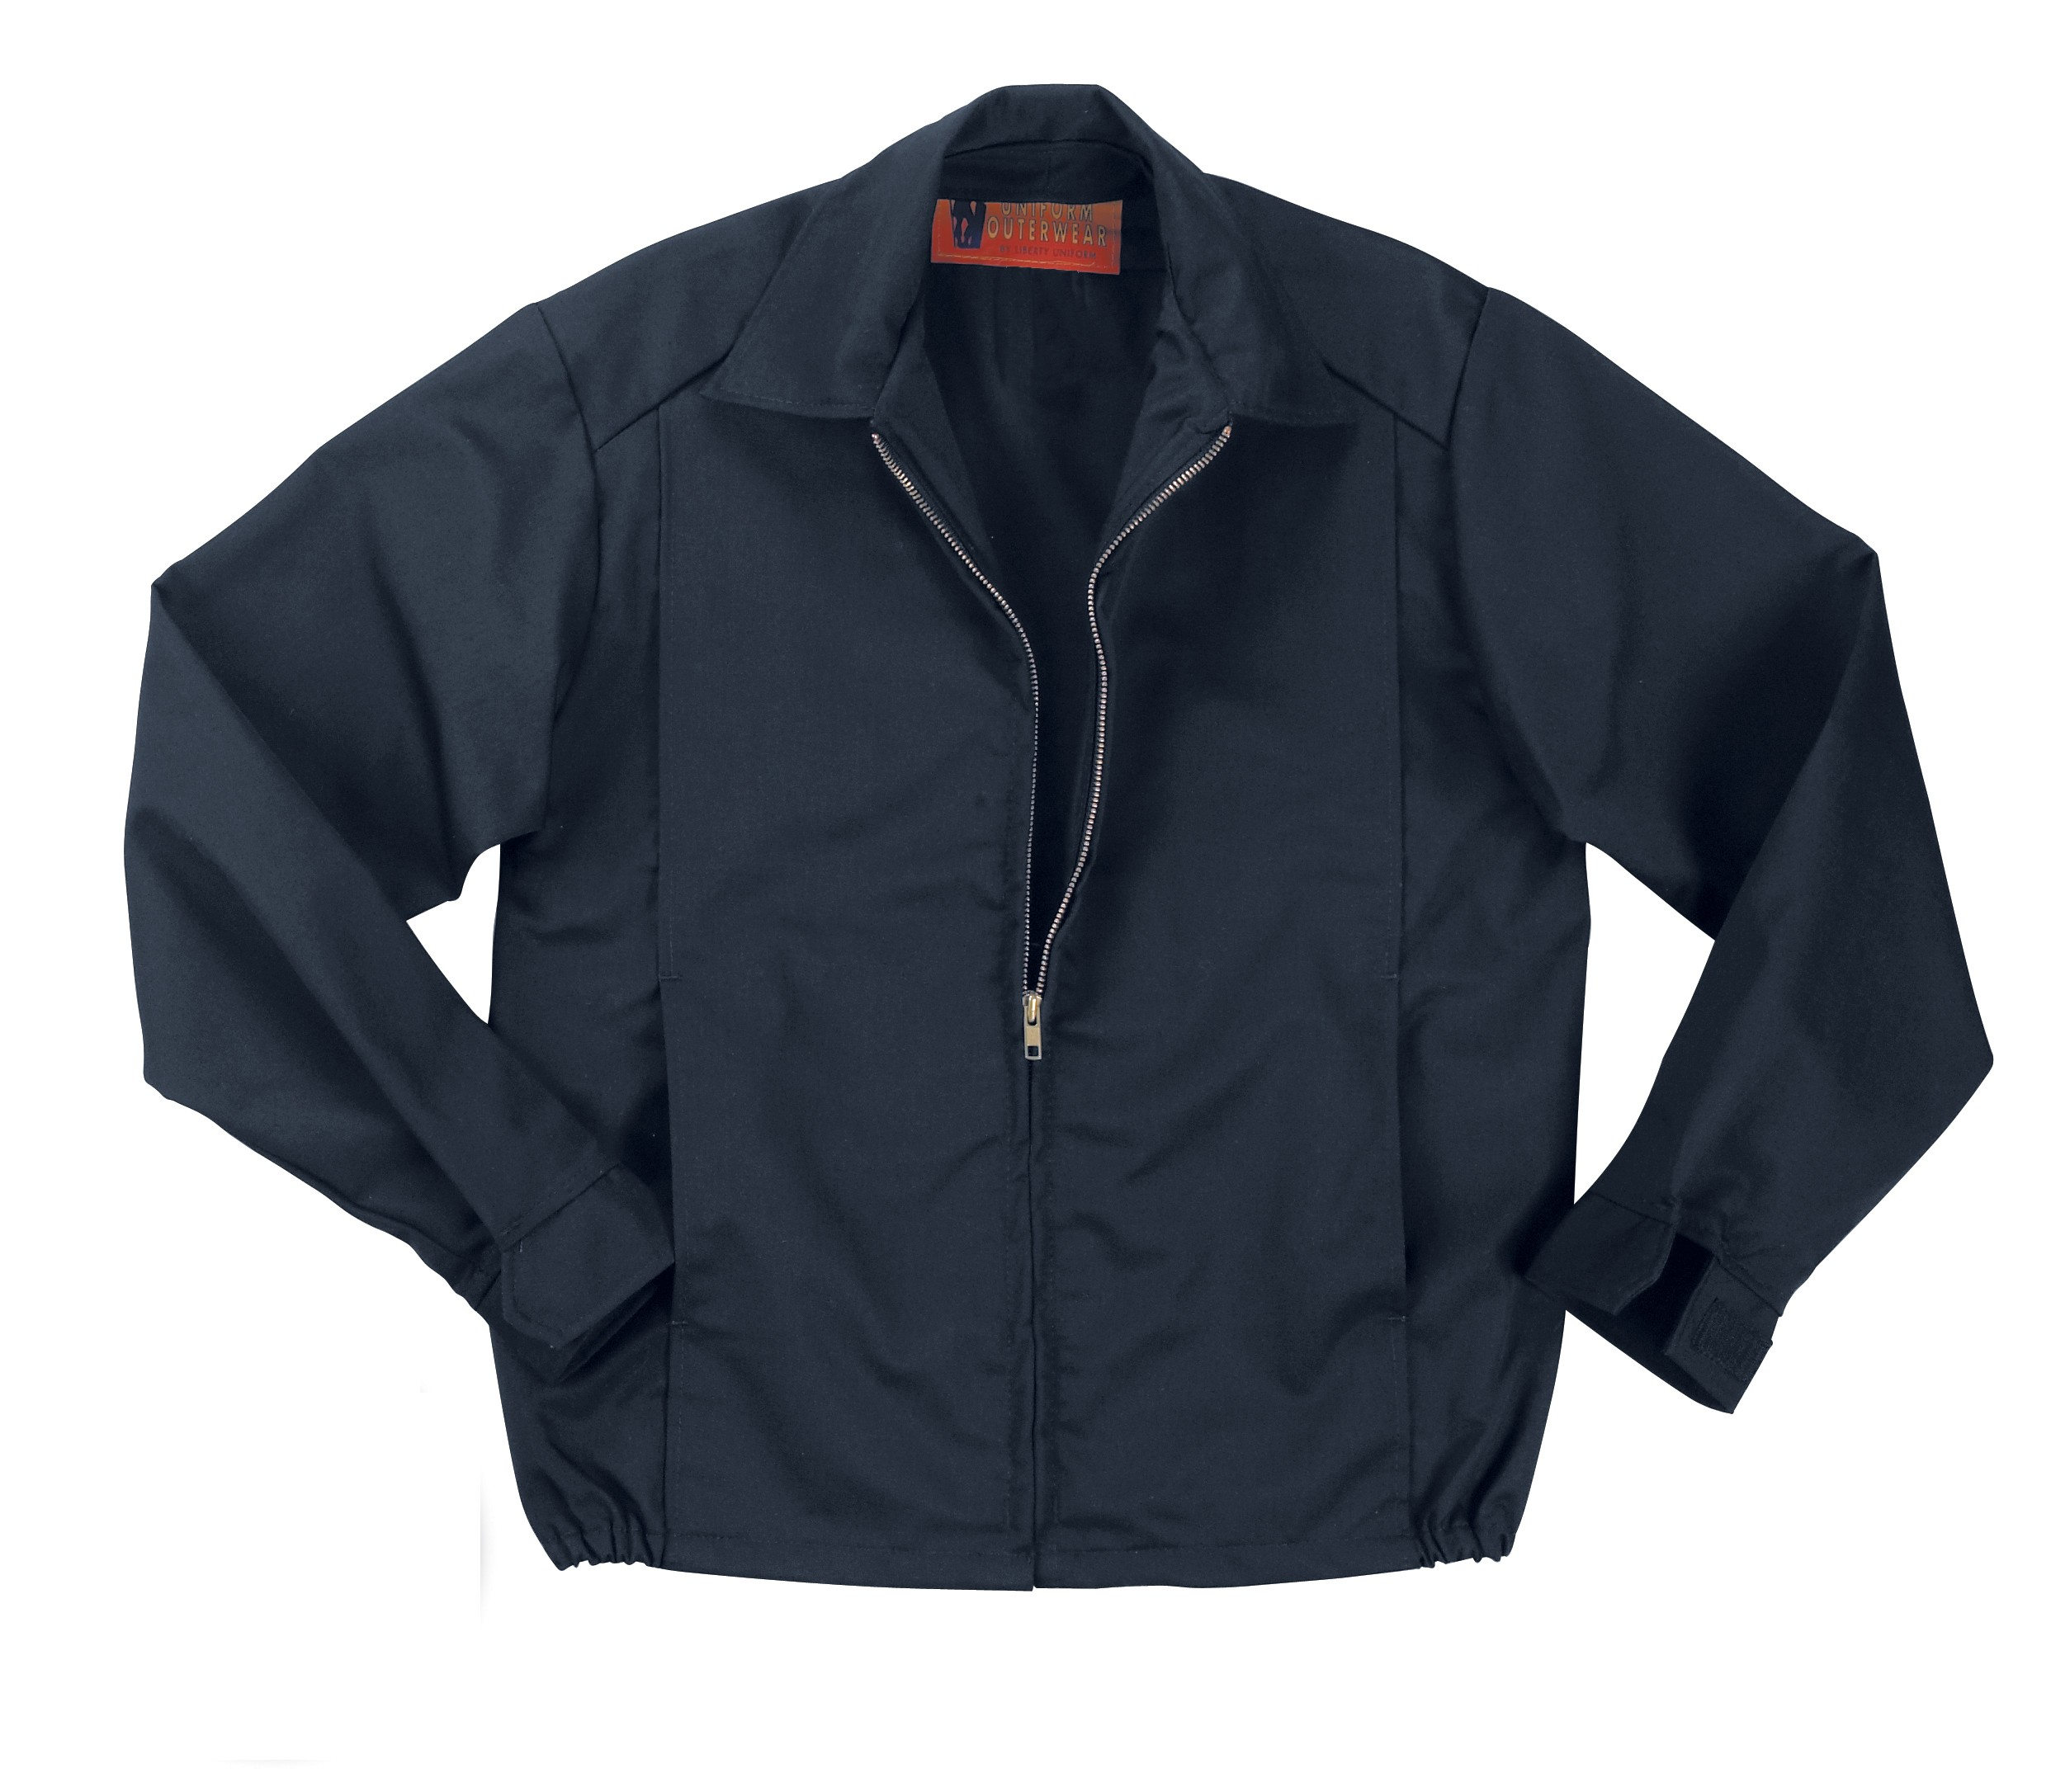

STYLE #: #550MNV – Navy

STYLE: Zipper front to neck, self fabric shirt style collar, open facing for optional zip-out liner, two lower vertical panel front pockets, shirred elastic inserts on side of waistband, adjustable Velcro® cuff

FABRIC:

Contents: 65% polyester, 35% combed cotton
Weight: 13 ozs./lin.yd.
7.8 ozs./sq. yd.
Weave: Twill
Dying: High-pressure jet dyed
Finish: LibertyGuard™ soil release

COLORS:
Navy blue

FRONT: There shall be a #5 solid brass zipper front with inside storm fly.

POCKETS: There shall be two (2) set in hand warmer pockets into the front panel seam. This seam runs from the shoulder seam to the bottom of the jacket. The pockets shall have an opening of 6 ¼”. Pocketing shall be made of shell material for extra strength. There shall be bartacks at the top and bottom opening of the pockets.

COLLAR: There shall be a shirt style, pointed, self-goods collar with a collar stand and a heavy non-woven interlining.

SLEEVES: Shall be one piece, set in style. There shall be adjustable cuffs of self-material. They shall close with Velcro®.

WAISTBAND: There shall be a shirred elastic insert into the side hem of the waistband. The front panels shall be plain with no waistband

OPEN FACING: There shall be an open facing made of shell material to accept an optional zip-out quilted lining.

SEWING/SEAMS: All main shell seams shall be overlock safety stitched. All remaining joining seams shall be chain stitched.

BARTACKS: There shall be bartacks on both sides of the base of the zipper and at all pocket corner openings.

THREAD: All thread shall be 3-ply, #50, poly-core thread, vat dyed.

FINISHING: This garment shall be finished in a first class workmanlike manner with all loose threads removed. The omission or apparent omission of any wording or specifications shall mean that only the highest quality industry standards shall be used on all fabric and component parts including labor. Where there may be a discrepancy between the standard sample and the written specification, the detail of the standard sample shall prevail.

LABELS: All labels will be permanent to withstand repeated cleanings for the life of the garment. The following labels shall be applied:

MAIN LABEL: This shall identify the manufacturer either by name & location, registered trademark or WPL or RN number as required by the Federal Trade Commission.

CONTENTS/CARE/SIZE LABEL: There shall be an additional label clearly showing the fabric contents, laundering instructions and garment size.

SIZES: Regulars: Small to 4X-large
Longs: Medium to 2X-Large

