SPECIFICTION

BLAZER – MALE

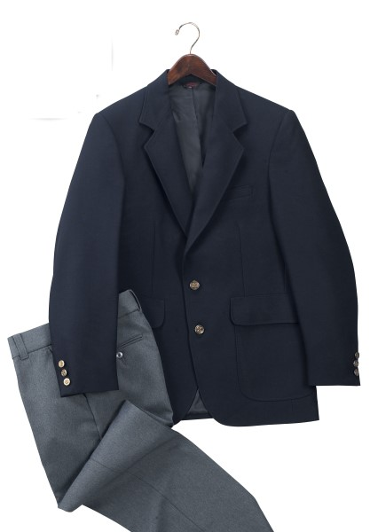

STYLE #: #540MNV – male, navy blue

STYLE: Single breasted, two (2) button front, notch lapel, vented back (male only), three (3) button sleeve with sleeve vent (male only), fully lined, two (2) patch pockets with flaps, one (1) breast welt pocket, two (2) inside breast pockets.

FABRIC:

Contents: 100% polyester

Construction: Warp = 78, Filling = 52
Yarns: Warp = single ply/150, Filling = 2-ply/150.
Weave: Plain
Weight: 4.5 ozs./sq. yd., 7.5 ozs./linear yd.
Finish: Stain release

POCKETS:
There shall be two (2) plain patch pocket averaging 7 ½” wide and 8 ¾” tall. This shall be fully lined with a non-woven material. They shall have rounded bottom corners. The flap shall be 7 ¾” wide and 2 ½” tall. The flap shall be lined with a nylon taffeta lining. The pocket and flap shall be top stitched 3/8”. There shall be a breast welt pocket averaging 4 ¼” wide and 1” high. This shall be top stitched 3/8”. The pocket bag shall be made of nylon taffeta and shall measure 5 ¼” deep. There shall be two (2) inside breast pockets, one on each front panel. These shall be Reece double welt style. The welt shall be made of shell material. The pocket bag shall be made of nylon taffeta and shall measure 5 ½” deep.

LINING: The blazer shall be fully lined with nylon taffeta.

SWING ACTION PANEL: There shall be an expandable knit mesh panel set between the back lining and the sleeve, from the shoulder seam to the underarm. This shall measure approximately 1 ¾” wide. The purpose will be to allow the lining to fully expand when the arms are moved forward.

FRONT: The front shall close with two (2) 30 ligne metal buttons.

COLLAR & LAPEL: The collar shall be lined with shell material and top stitched 3/8”. The lapel shall be a notch style and top stitched 3/8”.

SLEEVES: The sleeves shall be two-piece, set in style. They shall have an industry standard sleeve head and shoulder pad. The male sleeve shall have a vent opening with three metal buttons. The female sleeve shall have no vent.

VENT: The male coat will have a rear center vent averaging 11” in opening.

BUTTONS: The buttons shall be metal, 30 ligne, gold in color.

SEAMING: Except as noted above, all seams shall be single need, pressed open.

THREAD: All thread shall be poly-core, color fast, 2-ply. This shall identically match the color of the blazer.

INTERLINING: The fronts shall have commercial quality fusing and hymo chest pieces. All commercially accepted shoulder pads, sleeve heads, bridal tapes, fusings and interlinings shall be used throughout.

FINISHING: This garment shall be finished in a first class workmanlike manner with all loose threads removed. The omission or apparent omission of any wording or specifications shall mean that only the highest quality industry standards shall be used on all fabric and component parts including labor. Where there may be a discrepancy between the standard sample and the written specification, the detail of the standard sample shall prevail.

LABELS: All labels will be permanent to withstand repeated cleanings for the life of the garment. The following labels shall be applied:

MAIN LABEL: There shall be a main label. This shall identify the manufacturer either by name & location, registered trademark or WPL or RN number as required by the Federal Trade Commission.

CONTENTS/CARE/SIZE LABEL: There shall be an additional label on both the main jacket and removable liner clearly showing the fabric contents, laundering instructions and garment size.

PACKING & FOLDING: Blazers will be professionally pressed and shipped on hangers, flat packed. They shall be in polyester bags.

SIZES:

Short: 36-44
Regular: 36-60
Long: 38-64
X-Long: 40-48

