SPECIFICATION - MILLENNIUM JACKET #530

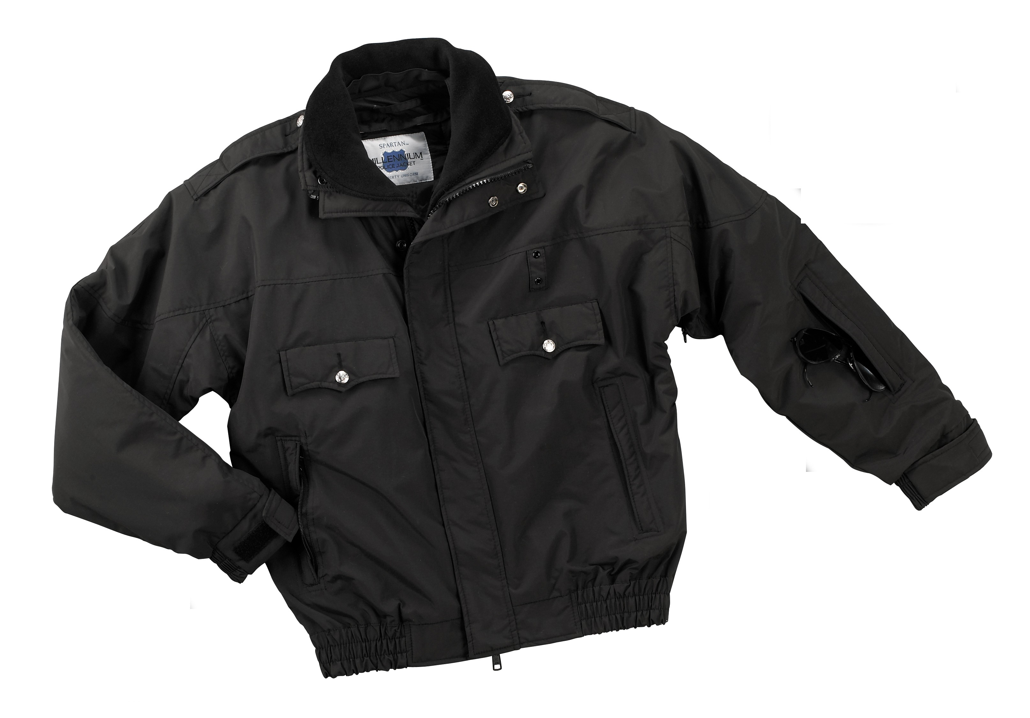

STYLE #: #530MBK - Black
#530MNV - Navy

STYLE: Cape top style with underarm zipper, mesh air vents, zipper front to top of collar, removable Polar Fleece® collar liner, double storm fly with hidden snaps, permanent nylon taffeta lining, removable Thinsulate® liner, two upper set-in scalloped flap pockets, two welted, vertical front zipper pockets, two welted, forearm zipper pockets, inside zippered utility pocket, epaulets, badge tab, elasticized sleeve cuff with adjustable tab, zippered side vents with snap tab closure at bottom.

FABRIC:

SHELL:

Contents: 100% nylon 3-ply Supplex®

Construction: Warp = 154, Filling = 64
Yarns: Warp = single ply/70, Filling = 3-ply/70.
Weave: Plain
Weight: 4.0 ozs./sq. yd.
Warp stretch: 4%
Filling stretch: 4%
Dying: High pressure jet dyed
Finish: Hydrofusion™ Fabric System: A specially engineered fabric with Durepel® water & stain resistant treatment on the face side and a micro-porous, polyurethane hydrophilic coating on the back side. The hydrophilic coating draws moisture away from the body and releases it outward. The fabric is durable, highly breathable, wind-proof and water-resistant. It passes the international rainwear tariff requirements under Homogenized Tariff Listing #5903.20.01. The benefits of the Hydrofusion™ fabric system must last through repeated washings.

REMOVABLE COLLAR LINER: 100% Polar Fleece®, 490 gm. weight.

LINING: 100% nylon taffeta
REMOVABLE LINER: Face and back is 100% nylon taffeta. Interlining is 200 gm. Thinsulate® body and 100 gm. Thinsulate® sleeves.

FABRIC TESTING MINIMUM STANDARDS:

Test Name, Reference Test Detail Specification
Colorfastness to Crocking Dry 4.0 or greater
AATCC 8 Wet 3.0 or greater

Colorfastness to light 20 hour 4.0 or greater
AATCC 16 - 1993 option A 40 hour 3.0 or greater

Colorfastness to perspiration - acid Shade change 4.0 or greater
AATCC 15

Test Name, Reference Test Detail Specification
Colorfastness to washing Shade change 4.0 or greater
(120°F wash fastness)

AATCC 61 - 1993

Colorfastness to water Shade change 4.0 or greater
(cold water bleed)

AATCC - 107

Colorfastness to solvent spotting 3.5 or greater
AATCC 157

120°F wash shrinkage 3 wash/dry cycles 4.0% or less
at 120°F

Elmendorf tear strength 1500 gm or greater
ASTM D1424

Roughing & Pilling 15 min. 4.0 or greater
ASTM D3512

Seam slippage 30 lbs. or greater
ASTM D434

Tensile strength 50 lbs. or greater
ASTM D5034

Air porosity 3.0 cfm or less
ASTM D737

Flammability - 16 CFR 1610 Class 1

Rain test - seepage 2 ft./2min. 1.0gm or less
AATCC 35

Spray test - repellency Original 90 or greater
AATCC 22 3x 80 or better
10x 70 or better

FRONT CLOSURE: There shall be a #10 nylon, non-reflective non-freeze 1-way zipper from the bottom of the jacket to the top of the collar. This shall form a turtleneck type collar when fully zipped. There will be an outside storm fly on the left front measuring 2 ½” wide from the bottom of the waistband to the top of the collar. This shall be interlined with a good commercial grade non-woven interlining. There will be a total of 7 hidden snaps under the fly to secure closed. These shall be non-rusting with a military oxidized finish. There will be an inside storm fly on the right front measuring 1 ½” wide from the bottom of the waist to the top of the collar. This shall be interlined with a good commercial grade non-woven interlining.

PATTERN: Cape top style pattern with underarm gussets for maximum arm movement without restriction. The back shall have seven (7) independent panels for a tailored fit.

LINING: The jacket shall have a permanent, full lining of 100% nylon taffeta.

REMOVABLE LINER: There shall be an open facing to accept a zip-out liner. The face and back material of the liner shall be made of 100% nylon taffeta. The body shall be interlined with 200 gm. Thinsulate® and the sleeves shall be interlined with 100 gm. Thinsulate®. The quilting pattern shall be a vertical stitch, spaced 4” apart. There shall be a knitted cuff at the end of each sleeve. There shall be two tabs with a snap attached to secure the liner sleeve to a loop inside the jacket sleeve. These tabs and loops shall be securely bar tacked on to prevent ripping out. There shall be an open side vent to coordinate with the zippered side vents on the jacket. There shall be an opening under each armpit to coordinate with the under arm zippered air vents in the jacket. All raw edges of the liner shall be bound with nylon taffeta bias binding. The zipper for the removable shall be a black, nylon coil zipper.

BADGE TAB: There shall be a badge tab affixed to the left chest of the jacket and made of shell material and color. It shall be ¾” wide and 2” long. It shall be set into the cape seam and shall be centered 1” above the left pocket flap. There shall be two metal eyelets spaced 1 ¼” apart.

UNDER ARM AIR VENTS: There shall be a zippered vent opening under each armpit allowing for individualized comfort. The opening shall be 5” long. The zipper shall be a black, nylon coil zipper. There shall be a piece of nylon mesh material sewn into the opening of this vent. The mesh shall be approximately 1 ¼” wide at the center when the zipper is open.

POCKETS:
FRONT BREAST POCKETS: There shall be two upper, set-in pockets with flaps. The pocket opening shall be 5 ¼” wide and 8” deep. There shall be a welt measuring 5 ¼” wide and ½” tall at the top opening of the pocket, secured with a bartack at each end. The pocket bag shall be made of a good commercial polyester/cotton, non-pill pocketing. The color of the bag shall be black. Each pocket will have a scalloped flap measuring 5 ¼” wide, 2 1/8” at the sides and 2 ½” to the center point. The flap will be topstitched 3/8” from all sides. Each flap will close with Velcro® at the corners. Each will also have a keyhole style buttonhole with a removable metal button. This shall be a non-functioning button.

FRONT HANDWARMER POCKETS: There shall be two lower, vertical, welted hand warmer pockets set approximately 8 ½” from the front zipper. The welts shall be 7 ½” tall and 7/8” wide and secured with a bartack at each end. There shall be a cord set into the front edge of the welt. There shall be a hidden black, nylon coil closure under the welt. The pocket bag shall be made of a good commercial polyester/cotton, non-pill pocketing. The color of the bag shall be black. The pocket welt will be framed with a ¼” topstitch.

FOREARM UTILITY POCKETS: There shall be a forearm utility pocket on each sleeve. The styling, details and dimensions are identical to the front hand warmer pockets listed above. The bottom of the welt shall be set 5 ½” above the bottom of the sleeve cuff.

INSIDE UTILITY POCKET: There shall be one set-in pocket on the left inside facing. This shall be a double-welted pocket with a black, nylon coil zipper closure. The functional pocket opening shall be a minimum of 6 ½” and the pocket depth shall be a minimum of 8 ½” measured from the top to the bottom of the pocket bag. The pocket bag shall be made of a good commercial polyester/cotton, non-pill pocketing. The color of the bag shall be black.

EPAULETS: There shall be an epaulet on each shoulder. These shall be made of shell material. They will be interlined with a good commercial non-woven material. They shall have a “X” stitch at one end and pointed by the collar. There shall be a removable metal button at the pointed end secured by a cotter pin. They shall average approximately 7 ½” long, 2” wide by the “X” stitch and taper to 1 ¾” at the pointed end.

COLLAR & COLLAR LINER: There shall be a stand up collar that is integrated into the outside and inside storm flies. When the collar is stood upright it shall form a turtleneck. The collar shall measure 4” tall at the center and 3 ½” tall at the sides. There shall be a good, commercial grade non-woven interlining between the top and bottom plies of fabric. The front zipper shall extend to the top of the collar when in an upright position. Attached to the collar on the inside of the neck will be a removable collar liner made of Polar Fleece®. This shall be backed with nylon taffeta. This liner shall match the dimensions of the collar. A black, nylon coil zipper shall secure it. There will be a fly cover over the zipper to protect the neck when the liner is detached.

SLEEVES & CUFFS: There shall be a one piece sleeve attached to a triangular underarm gusset and the cape top. Each sleeve will have a forearm pocket as described above. There shall be an attached sleeve cuff of shell material measuring 2” wide. This shall be interlined with a good, commercial grade non-woven material. The underside shall be shirred with 2” wide elastic approximately 3 ¼” in length. The top side shall have an adjustable tab made of shell material and shall be secured with 1” wide Velcro®.

WAISTBAND: The bottom of the jacket shall have a 2” side waistband from end to end. Approximately 4” from each zipper side shall be plain and interlined with a good, commercial grade non-woven interlining. The balance of the waistband shall be shirred with 2” wide elastic.

SIDE VENTS: There shall be a side vent on each side of the jacket. The opening shall be a minimum of 9 ½”. It shall close with a black, nylon, non-reflective, non-scratching coil zipper. There shall be a tab with a snap on the underneath side to secure the vent when the zipper is in the open position.

LOCKER LOOP: There shall be a locker loop made of shell material attached to the facing of the jacket at the neck seam.

SEAMING: All main joining seams shall be overlock safety stitched and then topstitched with a ¼” stitch on the outside.

THREAD: All thread shall be poly-core. All main seams shall use a #40 thread, and the balance #60.

BARTACKS: All pocket corners and flaps shall be properly bartacked.

FINISHING: This garment shall be finished in a first class workmanlike manner with all loose threads removed. The omission or apparent omission of any wording or specifications shall mean that only the highest quality industry standards shall be used on all fabric and component parts including labor. Where there may be a discrepancy between the standard sample and the written specification, the detail of the standard sample shall prevail.

LABELS: All labels will be permanent to withstand repeated cleanings for the life of the garment. The following labels shall be applied:

MAIN LABEL: There shall be a main label on both the main jacket and removable liner. This shall identify the manufacturer either by name & location, registered trademark or WPL or RN number as required by the Federal Trade Commission.

CONTENTS/CARE/SIZE LABEL: There shall be an additional label on both the main jacket and removable liner clearly showing the fabric contents, laundering instructions and garment size.

NAME LABEL: There shall be a label to write one’s name on the inside facing of the jacket.

PATTERN & SIZING: The pattern of this garment shall be such that:
- There is completely free arm movement & mobility with no restricting motions.
- The pattern will be sized so that a bulletproof vest may be worn underneath and not interfere with any body movement.
SIZES:
 |  |  | Back |  |  | Relaxed | Extended
Size | Chest | Sleeve | Length | Chest | Neck | Waistband | Waistband
Small | 34-36 | 35 | 27 | 46 | 19 | 30 | 44
Medium | 38-40 | 36 | 27 ½ | 50 | 20 | 34 | 48
Large | 42-44 | 37 | 28 | 54 | 21 | 38 | 52
X-Large | 46-48 | 38 | 28 ½ | 58 | 22 | 42 | 56
2X-Large | 50-52 | 38 ½ | 29 | 62 | 23 | 46 | 60
3X-Large | 54-56 | 39 | 29 ½ | 66 | 24 | 50 | 64
4X-Large | 58-60 | 39 | 30 | 70 | 25 | 54 | 68

Longs will be available from Medium to 4X-Large. In longs, the body will be 2” longer and the sleeves will be 2” longer than the above numbers.

