SPECIFICATIONS – Police Windbreaker

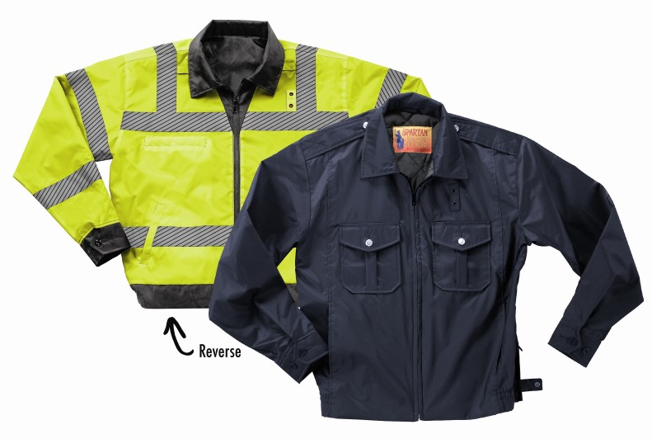
STYLE #: #524MBK – Black/fluorescent yellow
#524MNV – Navy/fluorescent yellow

STYLE:
OBVERSE SIDE: Zipper front to neck, self fabric shirt style collar, two (2) upper pleated patch pockets with flaps, two lower vertical panel front pockets, shirred elastic waistband, epaulets, adjustable button cuff, badge tab, side vent zippers.

REVERSE SIDE: Hi-vis fluorescent yellow with 2” silver segmented stripes: upper chest, lower body, upper sleeves, lower sleeve, over shoulders. Chest patch pocket, two lower slash pockets, badge tab, side vent zippers.

FABRIC:

Shell Contents: 100% polyester (full-dull)

Denier: 200 x 200 (yarn size)
Yarns: singles
Weave: Oxford
Dying: High-pressure jet dyed
Finish: Acrylic back coating & DWR face

Yellow side contents: 100% polyester, taffeta, 68 pick, 70 denier with 1,000 mm white back coating.

COLORS:
Black, reversing to yellow
Navy reversing to yellow

FRONT: There shall be a heavy-duty #5 heavy-duty black plastic molded non-freeze reversible zipper. A cord shall be inserted inside the fabric lip covering the zipper to assure that the slider does not catch on the fabric.

BADGE TAB: There shall be a badge tab affixed to the left breast of both sides made of shell material. There shall be small, black, round metal eyelets spaced 1 ¼” apart. The total badge tab dimensions shall be 2 ¼” high and ¾” wide.

POCKETS:
OBVERSE SIDE: There shall be two (2) upper breast pleated patch pockets with flaps. They shall be approximately 6” high and 5 ¼” wide. The pleat shall be 1 1/8” wide. The pointed flap shall be 2 ¾” high at the center and 2 ¼” high at the sides. The flap shall be secured with a removable metal button with cotter pin. There shall be bartacks at the top pocket corners. Both the pocket and the flaps shall be topstitched ¼” from the edge. There shall be a pencil opening in the top of the left flap, 1” wide.

There shall be two (2) set in hand warmer pockets into the front panel seam. This seam runs from the shoulder seam to the bottom of the jacket. The pockets shall have an opening of 6 ¼”. Pocketing shall be made of shell material for extra strength. There shall be bartacks at the top and bottom opening of the pockets.

REVERSE SIDE: There shall be one upper chest plain single welt pocket measuring 6” wide and 6” deep. The interlined welt shall measure 6” wide and 1” high with bartacks at either end. There shall be two lower slash hand warmer pockets with a single welt. The opening shall be 6” wide.

EPAULETS: There shall be two epaulets of self-material on the main side. These will be interlined. They shall have an “X” stitch by the shoulder seam and be pointed at the other end by the collar. There shall be a removable metal button at the pointed end. The epaulet will be tacked to the jacket at the pointed end.

COLLAR: There shall be a shirt style, pointed, self-goods collar with a collar stand and a heavy non-woven interlining.

SLEEVES: Shall be one piece, set in style. There shall be a two button adjustable cuff of self-material. The buttons will be back-to-back for reversible sleeve.

WAISTBAND: There shall be a 2” shirred elastic waistband beginning at a point 7” from the front zipper. The front panels shall be plain with no waistband. There shall be firm non-woven interlining inside the front bottoms between the shirred elastic and zipper front for firmness.

ZIPPER SIDE VENTS: There shall be zippered side vents measuring 11”. These shall close with a nylon coil reversible zipper.

SEWING/SEAMS: All main shell seams shall be overlock safety stitched. All remaining joining seams shall be chain stitched.

BARTACKS: There shall be bartacks on both sides of the base of the zipper and at all pocket corner openings and flap ends.

THREAD: All thread shall be 3-ply, #50, poly-core thread, vat dyed.

INTERLININGS: The epaulets, pocket flaps, pocket welt, collar, collar stand, waistband and cuffs shall be interlined with a heavy non-woven material.

FINISHING: This garment shall be finished in a first class workmanlike manner with all loose threads removed. The omission or apparent omission of any wording or specifications shall mean that only the highest quality industry standards shall be used on all fabric and component parts including labor. Where there may be a discrepancy between the standard sample and the written specification, the detail of the standard sample shall prevail.

LABELS: All labels will be permanent to withstand repeated cleanings for the life of the garment. The following labels shall be applied:

MAIN LABEL: This shall identify the manufacturer either by name & location, registered trademark or WPL or RN number as required by the Federal Trade Commission.

CONTENTS/CARE/SIZE LABEL: There shall be an additional label clearly showing the fabric contents, laundering instructions and garment size.

SIZES: Small to 4X-large and 6X-Large

