SPECIFICATIONS – Police Bomber jacket

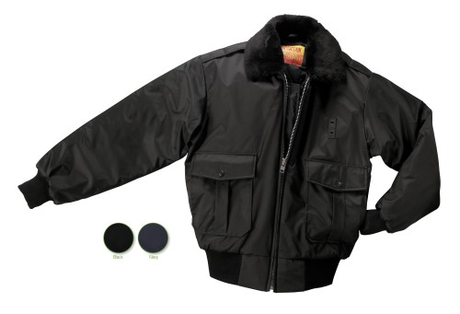

STYLE: Zipper front with inside storm fly, pile collar, quilt lined, two (2) slash pockets, knit waistband and cuffs, 28” average length.

FABRIC:

Shell Contents: 100% polyester (full-dull)

Denier: 200 x 200 (yarn size)
Yarns: singles
Weave: Oxford
Dying: High-pressure jet dyed
Finish: Acrylic back coating & DWR face

Lining contents: Face = 100% nylon taffeta, 68 pick
Quilt = 100% polyester fiberfill, 7.5 ozs.
Stitch = 6” diamond
Collar: 100% acrylic
Knit cuffs & band: 100% acrylic

COLORS:
#507MBK – black
#507MBN – Chocolate brown
#507MNV – Navy blue

FRONT: There shall be a heavy-duty #8 heavy-duty black plastic molded non-freeze zipper front with inside storm fly. A cord shall be inserted inside both fabric lips covering the zipper to assure that the slider does not catch on the fabric.

BADGE TAB: There shall be a badge tab affixed to the left breast made of shell material. This shall be small metal eyelets spaced 1 ¼” apart.

POCKETS: There shall be two (2) outside two-way pleated patch pockets with flaps. They shall be 8” high, 7” wide with a 6” wide side opening. The pleats shall be 1 ½” wide and stitched closed from the inside. The scalloped flap shall be 3” high at the center and 2 ½” high at the sides. The flap shall be secured with a center snap. The snap cap color shall be black. There shall be bartacks at the top pocket corners and bottom of the side opening. Pocketing shall be made of the shell material for extra strength. The back side of the pleated pocket shall have a nylon taffeta “facing” for comfort when the hand is inserted into the side opening pockets.

EPAULETS: There shall be two epaulets of self-material. These will be interlined. They shall have an “X” stitch by the shoulder seam and be pointed at the other end by the collar. The “X” stitch shall finish approximately 2 ½” long. There shall be a snap at the pointed end to secure to the shoulder. The color of the snap cap shall be black.

COLLAR: There shall be a permanent pile collar of matching color to the color of the jacket. This shall be “seal skin” quality, 24 oz. acrylic. The under collar shall be of shell material with a heavy non-woven interlining.

SLEEVES: Shall be one piece, set in style. There shall be an outside knit wristlet finishing 2 ¾”. The color shall match the color of the jacket.

WAISTBAND: There shall be an attached knit waistband. It shall begin and end approximately 3 ¾” from the front zipper edge. This double folded band shall be 3 ½” wide. There shall be a piece of shell material between the zipper and the beginning of the knit waistband. The knit shall be 100% acrylic, 1x1 rib knit with elastic strands every ½” to avoid stretching.

SEWING/SEAMS: All main shell seams shall be overlock safety stitched. All remaining joining seams shall be chain stitched.

BARTACKS: There shall be bartacks on both sides of the base of the zipper and at the ends of each pocket welt.

THREAD: All thread shall be 3-ply, #50, poly-core thread, vat dyed.

INTERLININGS: The pocket flaps, storm fly, waistband (between the knit and front edge) and collar shall be interlined with a heavy non-woven material.

FINISHING: This garment shall be finished in a first class workmanlike manner with all loose threads removed. The omission or apparent omission of any wording or specifications shall mean that only the highest quality industry standards shall be used on all fabric and component parts including labor. Where there may be a discrepancy between the standard sample and the written specification, the detail of the standard sample shall prevail.

LABELS: All labels will be permanent to withstand repeated cleanings for the life of the garment. The following labels shall be applied:

MAIN LABEL: This shall identify the manufacturer either by name & location, registered trademark or WPL or RN number as required by the Federal Trade Commission.

CONTENTS/CARE/SIZE LABEL: There shall be an additional label clearly showing the fabric contents, laundering instructions and garment size.

SIZES:
 | SM | MD | LG | XL | 2X | 3X | 4X | 6X
Chest -> | 34-36 | 38-40 | 42-44 | 46-48 | 50-52 | 54-56 | 58-60 | 66-68
Sleeve -> | 35 | 36 | 37 | 38 | 39 | 40 | 41 | 43

