SPECIFICATIONS – Security Bomber jacket w/epaulets

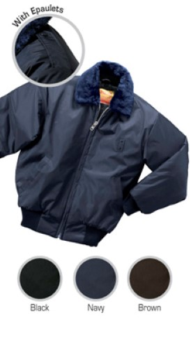

STYLE: Zipper front with inside storm fly, pile collar, quilt lined, two (2) slash pockets, knit waistband and cuffs, 28” average length.

FABRIC:

Shell Contents: 100% polyester (full-dull)

Denier: 200 x 200 (yarn size)
Yarns: singles
Weave: Oxford
Dying: High-pressure jet dyed
Finish: Acrylic back coating & DWR face

Lining contents: Face = 100% nylon taffeta, 68 pick
Quilt = 100% polyester fiberfill, 7.5 ozs.
Stitch = 6” diamond
Collar: 100% acrylic
Knit cuffs & band: 100% acrylic

COLORS: #506MBK – Black
#506MBN – Brown
#506MNV – Navy blue

FRONT: There shall be a heavy-duty #8 heavy-duty black plastic molded non-freeze zipper front with inside storm fly. A cord shall be inserted inside both fabric lips covering the zipper to assure that the slider does not catch on the fabric.

BADGE TAB: There shall be a badge tab affixed to the left breast made of shell material. This shall be small metal eyelets spaced 1 ¼” apart.

POCKETS: There shall be two (2) outside slash, single welt pockets. They shall be 7” wide with a 1” wide welt. Pocketing shall be made of shell material for extra strength.

EPAULETS: There shall be shoulder epaulets, made of shell material. They shall be approximately 2” wide at the shoulder seam, narrowing to 1 ½” before coming to a point at the end. They shall be sewn down at the shoulder seam and be affixed with a snap at the collar end.

COLLAR: There shall be a permanent pile collar of matching color to the color of the jacket. This shall be “seal skin” quality, 24 oz. acrylic. The under collar shall be of shell material with a heavy non-woven interlining.

SLEEVES: Shall be one piece, set in style. There shall be an outside knit wristlet finishing 2 ¾”. The color shall match the color of the jacket.

WAISTBAND: There shall be an attached knit waistband. It shall begin and end approximately 3 ¾” from the front zipper edge. This double folded band shall be 3 ½” wide. There shall be a piece of shell material between the zipper and the beginning of the knit waistband. The knit shall be 100% acrylic, 1x1 rib knit with elastic strands every ½” to avoid stretching.

SEWING/SEAMS: All main shell seams shall be overlock safety stitched. All remaining joining seams shall be chain stitched.

BARTACKS: There shall be bartacks on both sides of the base of the zipper and at the ends of each pocket welt.

THREAD: All thread shall be 3-ply, #50, poly-core thread, vat dyed.

INTERLININGS: The pocket welts, storm fly, waistband (between the knit and front edge) and collar shall be interlined with a heavy non-woven material.

FINISHING: This garment shall be finished in a first class workmanlike manner with all loose threads removed. The omission or apparent omission of any wording or specifications shall mean that only the highest quality industry standards shall be used on all fabric and component parts including labor. Where there may be a discrepancy between the standard sample and the written specification, the detail of the standard sample shall prevail.

LABELS: All labels will be permanent to withstand repeated cleanings for the life of the garment. The following labels shall be applied:

MAIN LABEL: This shall identify the manufacturer either by name & location, registered trademark or WPL or RN number as required by the Federal Trade Commission.

CONTENTS/CARE/SIZE LABEL: There shall be an additional label clearly showing the fabric contents, laundering instructions and garment size.

SIZES:
 | SM | MD | LG | XL | 2X | 3X | 4X | 6X
Chest -> | 34-36 | 38-40 | 42-44 | 46-48 | 50-52 | 54-56 | 58-60 | 66-68
Sleeve -> | 35 | 36 | 37 | 38 | 39 | 40 | 41 | 43

