SPECIFICATION

POLICE STYLE SWEATER

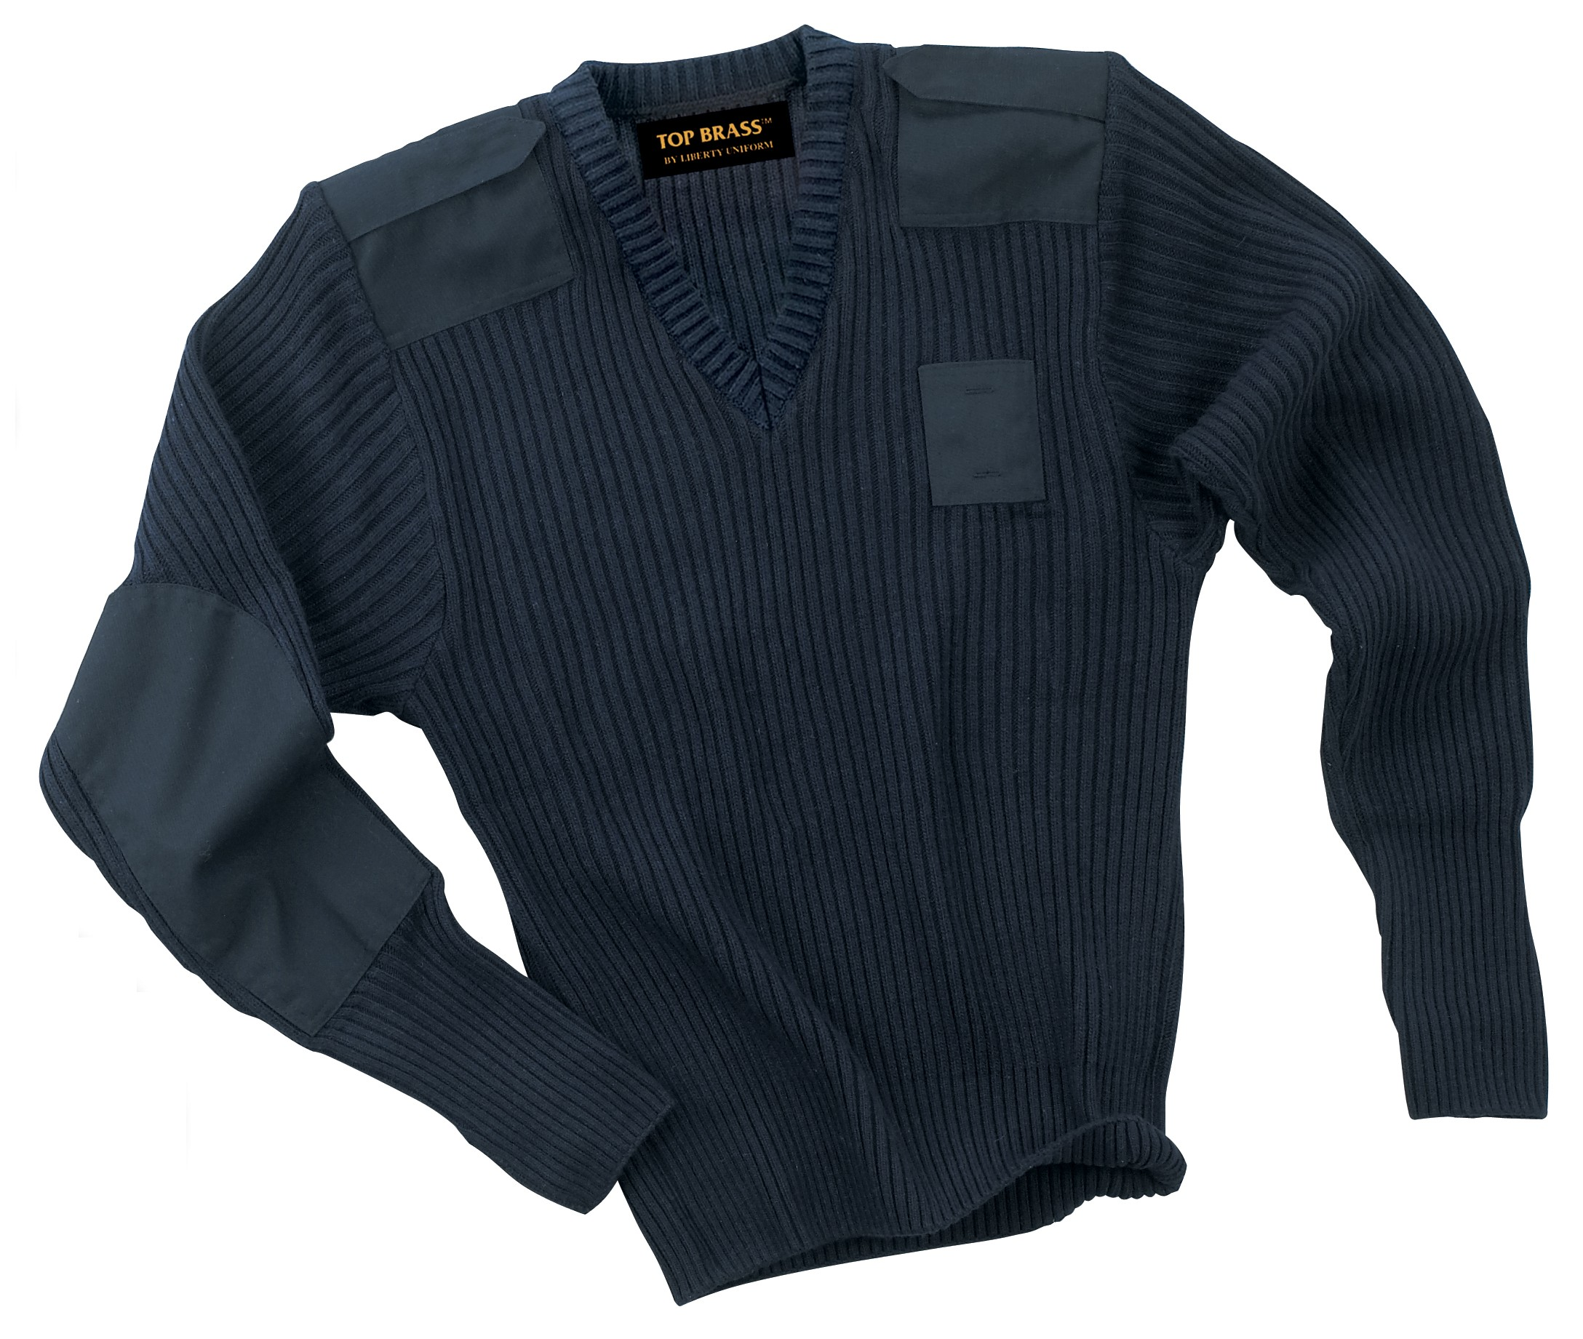

STYLE #: #140MBK – Black

#140MBN - Brown
#140MNV - Navy

STYLE: V-neck, pullover sweater, epaulets, shoulder patch, elbow patch and badge patch all of polyester/cotton material.

FABRIC:

Contents: 100% low pill acrylic
Knit: 2x2 rib for body & sleeves
Change to 1x1 rib, or tighter knit to form the waistband
Weight: 700 grams per square meter minimum

FRONT: There shall be a V-neck opening. The welt shall measure 1 ¼” wide.

PATCHES: There shall be shoulder patches of a polyester/cotton material of a matching color to the sweater. They shall cover the shoulder between the sleeve seam and the neck welt. It shall be approximately 9” long over the shoulder from front to back, evenly spaced on the front and back. It shall be applied with double needle stitching, spaced ¼” apart. It shall average 5 ¾” wide from neck to shoulder.

There shall be elbow patches of a polyester/cotton material of a matching color to the sweater. These shall average 4 ¾” wide and 11” long. It shall be applied with double needle stitching, spaced ¼” apart.

There shall be a badge patch sewn onto the left chest of a polyester/cotton material of a matching color to the sweater. It shall measure 2” wide and 3” tall. There shall be two sewn in eyelets spaced 1 ¾” apart, centered top to bottom.

There shall be a name patch prepared with each sweater of a polyester/cotton material of a matching color to the sweater. This shall measure 2” by 3” and attached to the sweater with a Dennison® gun, for application if needed.

EPAULET: There shall be epaulets on the shoulder made of a polyester/cotton material of a matching color to the sweater. They shall measure 2” wide at the shoulder seam and taper to 1 ½” wide near the neck. They, they shall come to a point and finish at the neck seam. They shall be set into the shoulder seam at one end and secured with Velcro® at the pointed end. The epaulet length shall match the width of the shoulder patch from sleeve seam to neck.

SLEEVES: There shall be a one-piece sleeve, set-in style. The overlock stitching on the inseam of the sleeve shall be on the outside of the sleeve cuff for a full 6” from the end. This will allow the cuff to be worn either open or cuffed.

SEAMING: All armhole and shoulder joining seams shall be overlock safety stitched. All patches shall be double needle sewn, spaced ¼” apart.

THREAD: All thread shall be poly-core, cotton wrapped and color fast.

FINISHING: This garment shall be finished in a first class workmanlike manner with all loose threads removed. The omission or apparent omission of any wording or specifications shall mean that only the highest quality industry standards shall be used on all fabric and component parts including labor. Where there may be a discrepancy between the standard sample and the written specification, the detail of the standard sample shall prevail.

LABELS: All labels will be permanent to withstand repeated cleanings for the life of the garment. The following labels shall be applied:

MAIN LABEL: This shall identify the manufacturer either by name & location, registered trademark or WPL or RN number as required by the Federal Trade Commission.

CONTENTS/CARE/SIZE LABEL: There shall be an additional label clearly showing the fabric contents, laundering instructions and garment size.

SIZES:
 | SM | MD | LG | XL | 2X | 3X | 4X | 5X
Chest | 35 | 39 | 43 | 47 | 51 | 55 | 59 | 63
Out sleeve | 35 | 36 | 37 | 38 | 39 | 40 | 41 | 42
Length | 25 | 26 | 27 | 28 | 29 | 30 | 31 | 32

